# Apps Included with Windows 8

Apps Included with Windows 8 1

App Details 4

Camera 4

Reader 9

Try This: Camera, Reader 11

Xbox Games 11

Home Screen and Game sections 12

Xbox Live Account sections 19

Settings 22

Try This: Xbox Games 24

Music and Video 25

Adding Additional Music 34

Settings 36

Try This: Music and Video 37

Bing Apps 37

Bing App 38

News 44

Sports 46

Maps 49

Weather 51

Travel 53

Finance 57

Try This: Using Bing Apps 60

Communications Apps 60

Mail 64

People 84

Calendar 100

Messaging 108

Photos 110

Photos App Details 111

Try This: Photos 114

SkyDrive 114

SkyDrive Details 116

#### Timing for This Module

|  |  |
| --- | --- |
| Delivery Length: 120 Minutes | Additional Lab Time: 45 Minutes |

#### Overview

In order to ensure the best possible experience for new users, the Windows® 8 operating system will include several Windows Store apps preinstalled. While these apps come from several different teams inside of Microsoft®, including Bing® and Xbox®, they are considered to be a part of Windows, and will be supported by Windows support.

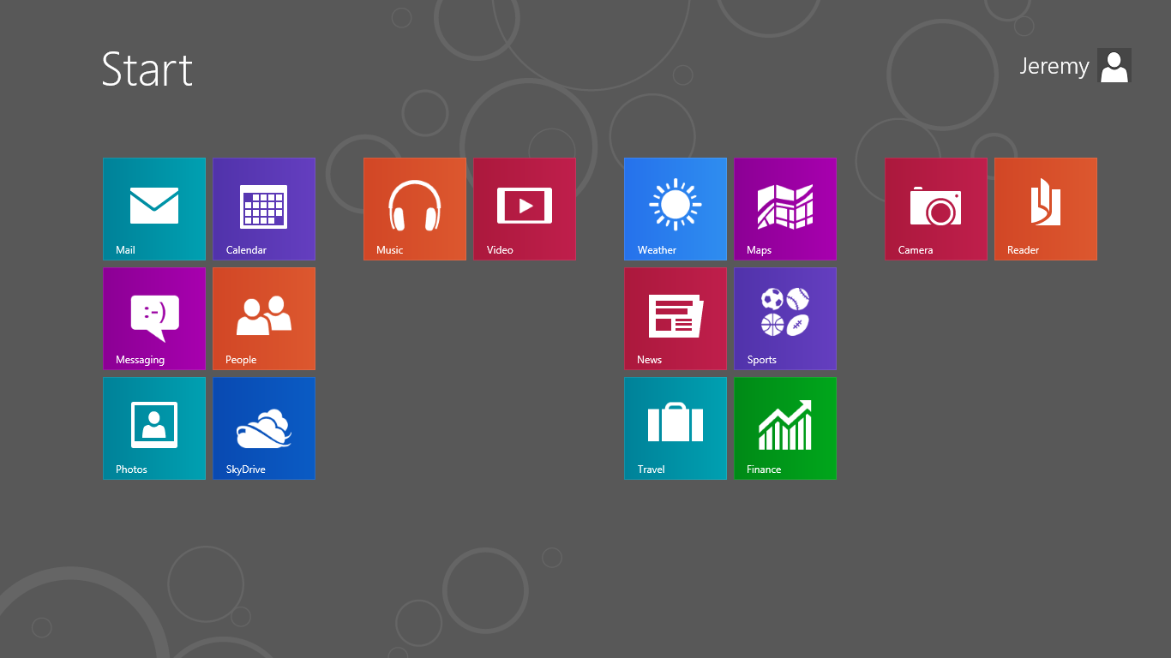

Figure : Apps included with Windows 8

This list below shows the apps that will be preinstalled with Windows 8.

Table : Apps included with Windows 8

|  |  |
| --- | --- |
| Mail | Music |
| Calendar | Video |
| Messaging | Finance |
| People | Maps |
| Photos | News |
| SkyDrive | Sports |
| Camera | Travel |
| Reader | Weather |
| Bing | Games |

There will be additional apps in the Windows Store from various Microsoft teams, but they will be supported separately.

In this module, you will see an overview of the apps that will be preinstalled with Windows 8, and any key points you might need to know in order to support the apps.

**Note:** The apps that are covered in this module are shown as they existed at the time of this writing. Like other apps in the Windows Store, it is likely that these apps will receive frequent updates that add or change the functionality that have shown here. As a result, the app you see installed on your PC may not exactly match that app as it is covered here.

## App Details

The apps that are preinstalled with Windows 8 are installed in much that same way that our OEM partners will preinstall their own apps on the PCs they sell. These apps operate much like any other app from the Windows Store:

* They can be uninstalled and then reinstalled from the Windows Store.
* They are updated through the Windows Store.
* They support Live tiles, Contracts, and run inside of a secure AppContainer just like any other Windows Store app.
* They can be pinned and unpinned from the Start screen.

This should make the experience of troubleshooting any of these apps much the same as supporting any other app in the Windows Store.

## Camera

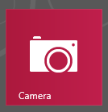

Figure : Camera tile

With the Camera app, you can use Windows 8 to take photos or shoot video. The Camera app allows you to take pictures or videos using either the embedded camera in your device, or an externally attached USB webcam device.

Camera is designed so that you can get into the app and take a picture as quickly as possible. The Camera app is similar in concept to most camera apps in mobile phones. When you first open the app, the default camera is activated and displays an image preview in full screen. This image preview shows you what the attached camera sees at the time. Simply tapping anywhere on the image preview will take a picture for you.

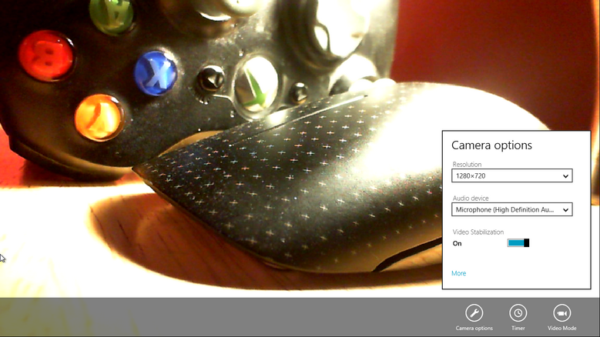

Figure : Camera app

When you swipe up from the bottom or right-click, you see the following app commands:

* **Video Mode**. Enabling this option switches Camera from taking still photos to recording video. Just tap the screen to start recording, then tap it again to stop.
* **Timer**. Using this option causes Camera to delay for three seconds before snapping a picture or starting the video recording.
* **Camera options**. This opens a basic menu of options for your camera, including image resolution and audio source for video:
  + These options will apply to both pictures and video.
  + Clicking the **More** link will expose additional options for your Camera. Not all options may be available, depending on the type of camera you are using.
  + The following screen shot shows the additional Camera options that are shown for the Microsoft LifeCam Cinema.

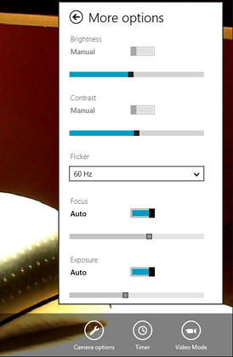

Figure : Camera options

After taking a picture or shooting a video, you can view that media by swiping to the left or by clicking the left arrow that is shown on the screen. Continuing this motion will let you browse through all of the images and videos that have been taken with the Camera app. When viewing pictures or videos, you have some editing options available to you when you select the screen. The options will be different, depending on if you have an image or video selected.

The options displayed when you select an image are **Crop** and **Delete**.



Figure : Crop and Delete options

**Delete** does just what it says. **Crop** displays four dots on the screen that you can use to select the area of the image you would like to crop to; after which, you just select **OK** to complete the crop.



Figure : Crop an image.

For videos, tapping the screen will start playing the video. Tapping the screen again while the video is playing reveals a **Play/Pause** button in the center of the screen, as well as a media transport bar, a **Trim** button, and a **Delete** button. You can use the media transport bar to navigate to a specific section of the video, and again, the **Delete** button does what it says. **Trim** enables you to edit the video by trimming it down to just the section you specify. Selecting the **Trim** button switches the media transport bar to editing mode, which adds a white dot at the beginning and end of the bar. You can move these dots in toward each other to specify the section of the video you would like to keep, as shown in the following screen shot.

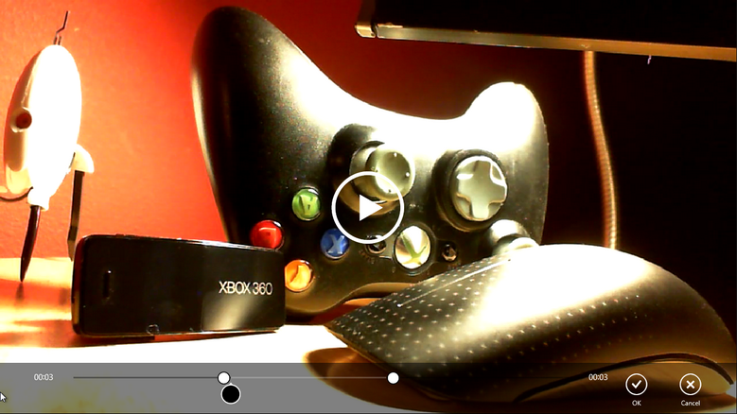

Figure : Trim a video

All pictures and videos taken with the Camera app are saved to the Webcam folder in your Pictures library:

%UserProfile%\Pictures\Camera Roll.

The default file name is either the word picture or video followed by a three-digit number that is automatically incremented with each new image or video. For example, picture054.jpg or video132.mp4:

* For images, the file type that is used is JPEG.
* For videos, the video stream is h.264 MPEG-4, the audio stream is AAC MPEG-4, and the container is an MP4 file.

## Reader



Figure : Reader tile

The Reader app is an XPS and PDF reader for the new Windows Experience. You can use this app to either browse for and view PDF/XPS files, or it can be used as the file handler for PDF/XPS files so when you open a PDF from the desktop or another app, it will open in Reader.

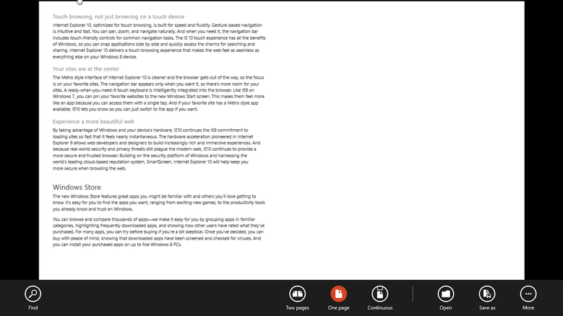

Figure : Reader app

When you first open the app, it is empty, except for the Browse tile. The Browse tile will open the new Windows 8 file picker, which you can use to browse the local PC or across the network to find your document. If an app has registered in the file picker, you can also browse the files exposed through that app using the file picker. SkyDrive® is an example of an app that has registered with the file picker, enabling you to open PDF/XPS documents on SkyDrive directly from within the Reader app.

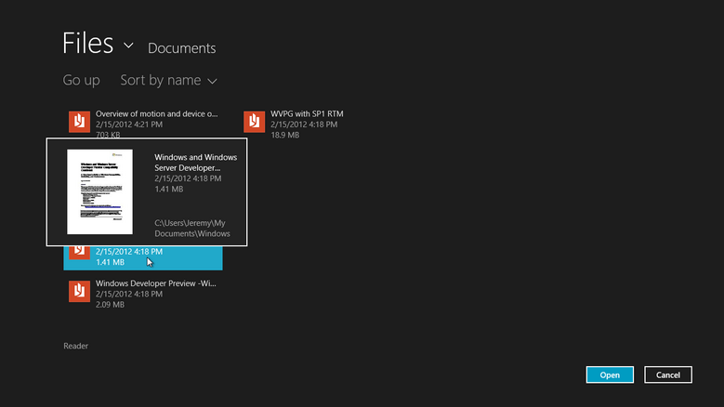

When reading a PDF or XPS file, you can access several of the commands used to customize your reading experience by bringing up the app commands at the bottom of the screen.



Figure : Reader app commands

* **Find**. This command allows you to search within the document.
* **Two pages, One page, and Continuous**. These commands change the way that the pages are displayed when reading.
* **Open**. Takes you back to the Home screen for the app, where you can either browse for a new document or open a recent one.
* **Save as**. Allows you to save a currently opened document in either an alternate location or with a new file name.
* **More**. This expands the menu and adds the following options:
  + **Rotate**. Rotates the document 90 degrees counter-clockwise.
  + **Info**. Display basic information about the document like file name, create date, size, number of pages, and DRM permissions.
  + **Bookmarks**. If bookmarks are defined for a given document, the **Bookmarks** option will display and allow you to browse through the bookmarks in the document. This is typically the heading structure for the document.
  + **Close file**. Closes the file and takes you back to the Reader home screen.

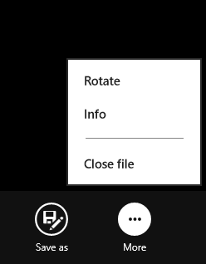

Figure : Reader options

## Try This: Camera, Reader

* Find a PC in the classroom that has a camera, and use that PC to take pictures and a video:
  + Crop a still photo.
  + Trim a video.
  + Change the resolution of the camera and take a smaller image.
* Download a PDF or XPS file from the Microsoft Download Center and open it in Reader:
  + Rotate the document.
  + Identify if bookmarks are available for the document.

## Xbox Games

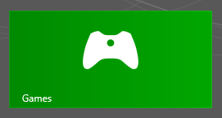

Figure : Xbox Games tile

The Xbox Games app, also called the Games app, provides a way for you to find new games for Xbox Live, view your Xbox Live account, and interact with your Xbox Live friends. You can use this app to see the statistics for all of the games that you've played on both the Xbox as well as PC games that supports Xbox Live. There are several Xbox Live games available in the Windows Store for Windows 8 at launch, including games like Pinball FX2, Solitaire Collections, and Mahjong Classics.

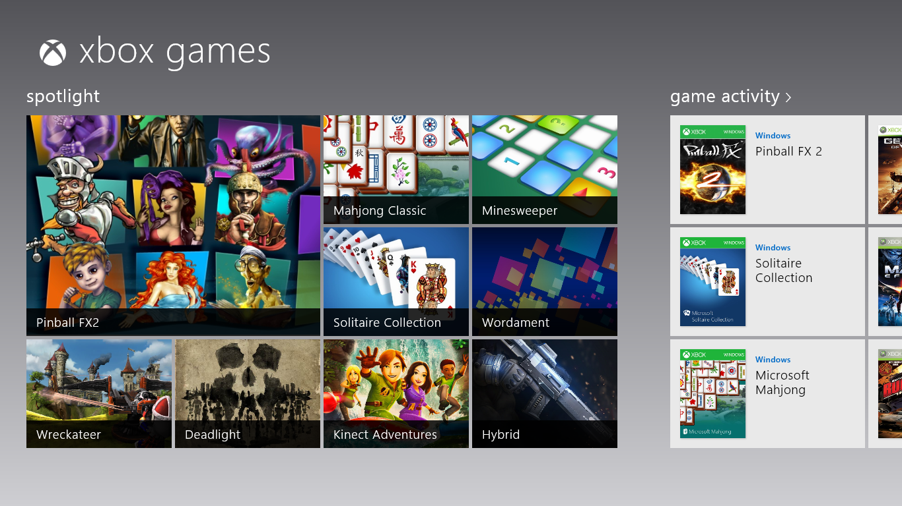

Figure : Xbox Games app

### Home Screen and Game sections

The home screen for the Games app is divided into several different sections with an interface very similar to the Xbox 360.

* The **Spotlight** section shows tiles for many of the currently featured games on Xbox Live, both for the Xbox 360 and your PC.
* The **Game Activity** section will show you the most recently played games played on Xbox live. This will include a mix of both windows and Xbox 360 games.
* The **Windows Game Store** section displays a collection of the Windows games that support Xbox Live that are currently being spotlighted. Selecting the link at the top will take you to a page where you can browse more of these games.
* The **Xbox 360 Games Store** section is similar to the Windows Games Store, but with a focus on games for the Xbox 360 Console. Again, clicking the title header will take you to a page where you can browse many more of the games available for the Xbox 360.

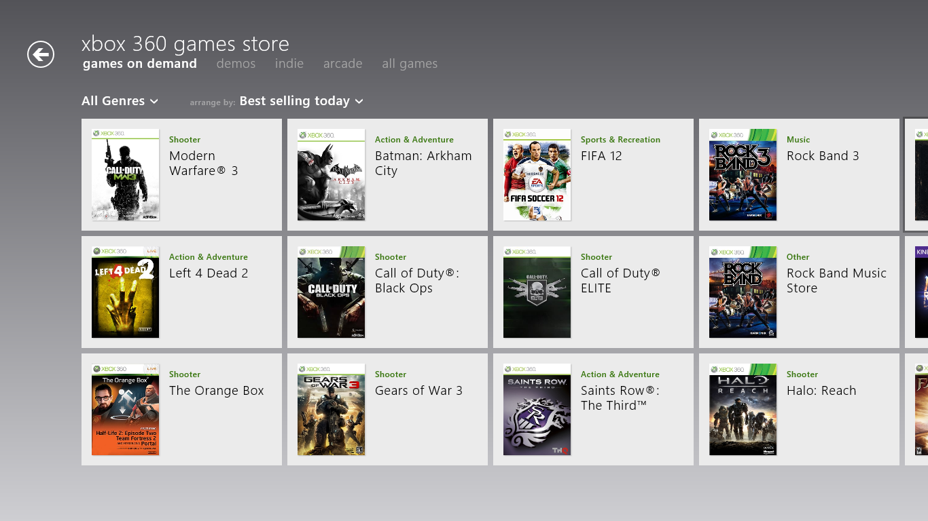

Figure : Xbox 360 Games Store

As you can see in the screen shot above, there are several tabs you can use to change the view to either Games on Demand, Demos, Indie games, Arcade Games, and All Games. Within each tab you have the ability to further filter and sort the list of games by criteria like genre, release date or rating.

When you select any of these tiles, you are shown a popup showing a summary of the game and the actions you can take against that game.

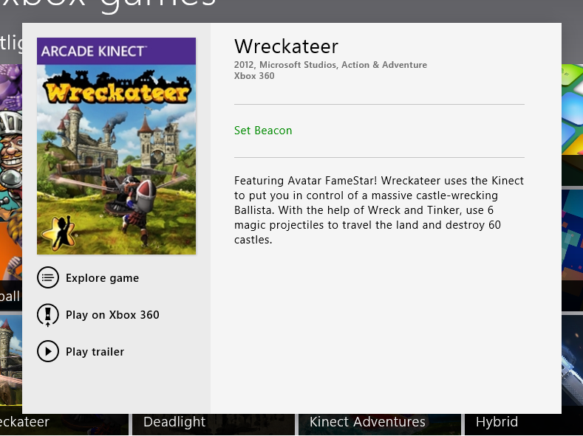

Figure : Game summary and available actions

The specific actions that you see in this popup will vary depending on the type of game that you select. We’ll explore those differences in the paragraphs below.

When you select a Windows game, you will see options to **Play** the game, and you can use **Explore game** to switch to the game’s home page in the app.

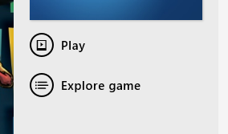

Figure : Options for Windows Game

The behavior of the **Play** button will depend on whether or not you actually have the game installed.

* If the game is installed, then it will be launched and you can begin playing.
* If the game is not installed, clicking play will display a prompt indicating that **No apps are installed to open this type of link**. There will also be an option to get the game from Store. Clicking this button will take you to the Windows Store where you can download and install the game. After installing the game, clicking **Play** again in the Xbox Games app opens the game. You will of course also be able to launch the game directly from the Windows 8 Start Screen.

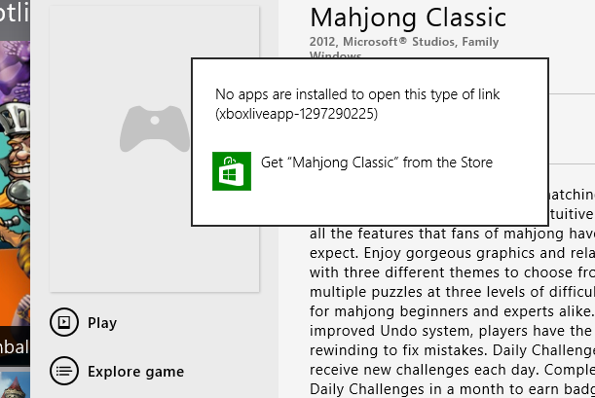

Figure : Game is not installed

The available actions displayed for Xbox games will depend on multiple variables, including the following:

* Type of game – Xbox 360 game on DVD, Games on Demand, Arcade, Indie, Demo
* Is the game available for download?
* Is a trailer available for the game?

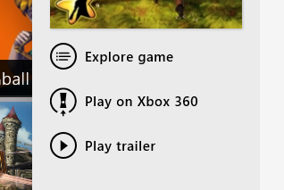

Figure : Options for Xbox games

Xbox 360 games are normally available on a disk, but the Xbox also supports Games on Demand, which allows you to download these games to your Xbox 360's hard drive. If the game is available through Games on Demand, an option will be displayed to **Buy game for Xbox 360**. This will take you through an experience in the Xbox Games app where you can purchase the game, and then the game will be available for download on your Xbox.

The **Play on Xbox 360** option is shown for Xbox 360 games, Xbox Live Arcade games, Indie games, and Demos. Selecting this option will attempt to open the Xbox SmartGlass app which can then be used to launch the game.

If the Xbox SmartGlass app is not installed, you will see you a dialog indicating that **No** **apps are installed to open this type of link (xboxsmartglass)**. In the same pop-up is a button that will take you directly to the product description page for the Xbox SmartGlass app in the Windows store. Otherwise, if the app is already installed, it will simply be launched.

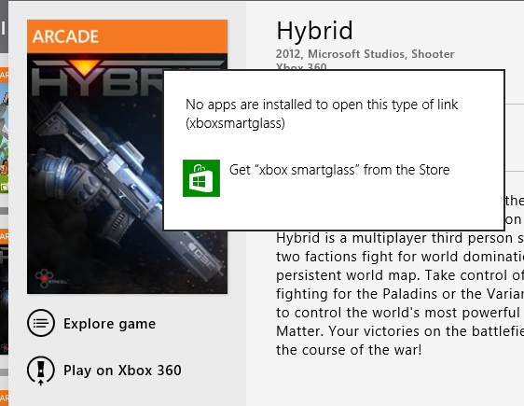

Figure : SmartGlass is not installed

Once Xbox SmartGlass has connected to your Xbox 360, the next action will depend on whether or not you have already purchased the game.

* If you already own the game and it is installed, the Xbox will just open the game.
* Otherwise you will be taken through the process of purchasing the game. Purchase is not automatic, and you will still need to confirm your purchase on the Xbox itself.

|  |
| --- |
| **Note**: Xbox SmartGlass is an app available from the Windows Store that can be used to remotely control your Xbox 360, using it to watch games or navigate through any of the apps available on the Xbox 360. Some content on the console will provide a secondary experience through SmartGlass. For example, you might be playing an American football game on your Xbox 360, and using SmartGlass on your Windows 8 PC you can do things like select your next play or see statistic on a specific play that is on the field right now.  Xbox SmartGlass is not included in the box with Windows 8 and is supported by the Xbox support team. |

If a trailer is available for the game, the **Play trailer** button will be visible.

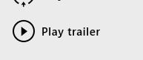

Figure : Play Trailer button

Clicking on this button will display the trailer in the app

The **Set beacon** option that is used to let's your Xbox Live friends know that you would like to play the game online.

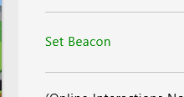

Figure : Set Beacon link

Every game has an **Explore game** button which takes you to a page with information about the game

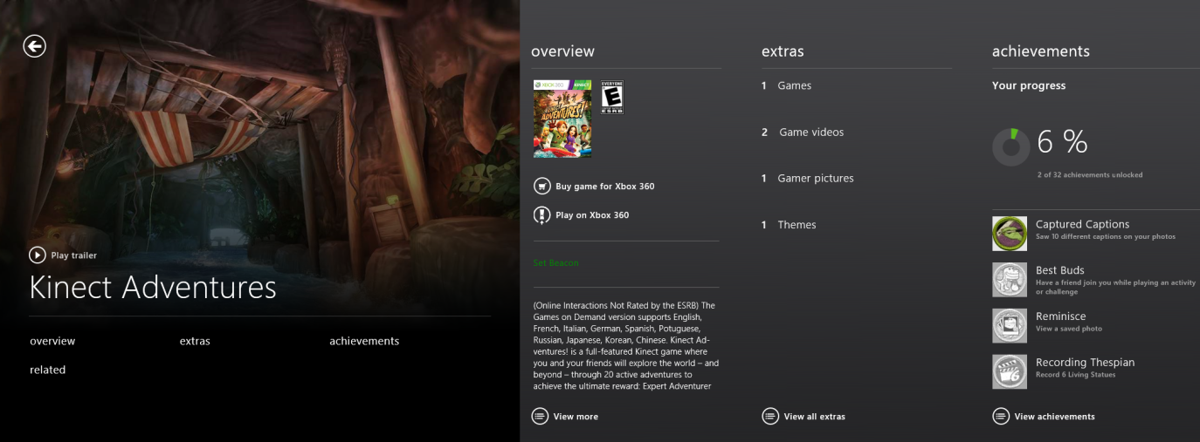

Figure : Expanded view of the Explore game page

The **Explore game** page includes the following.

* If a trailer is available for the game, the **Play trailer** button is displayed on the Explore game page in the app.
* **Overview** which provides a description of the game, the rating for the game, a **Play on Xbox 360** button, and an option to **Set Beacon**, which will tell your friends that you want to play this game on Xbox Live.
* **Extras**, which shows all of the additional downloadable content that is available for the game, including demos, videos of gameplay or trailers, avatar items, and new missions or characters.
* **Achievements** displays a list of all of the achievements that are available for the game. If you have already been playing this game, this page will also show you the Achievements that you have earned, as well as your progress towards obtaining all of the achievements for the game.
* If you are already enjoying a particular game, you can use the **Related** section to see a list of several other games available that are similar to the one you were playing.

### Xbox Live Account sections

All the areas that we've discussed so far have involved scrolling right from the Spotlight section of the home screen. When you scroll to the left you transition from game focused sections to account focused sections.

In order to be able to view details from your Xbox Live account, you need to sign into the Games app with the Microsoft Account that is associated with your Xbox Live Gamertag. If you are using a Connected Account, then you will automatically be signed in using the account you use to sign in to Windows. Otherwise, you will need to enter your Microsoft Account credentials. You will still be able to browse the games in the app without being signed in, but it won’t show any information specific to your Gamertag or friends.

**Note**: If the Microsoft Account that you sign in with does not already have a Xbox Live account associated with it, one will be created automatically when you sign into the app. The Gamertag for this account will be automatically generated and the account will be given an Xbox Live Silver membership. Xbox Live Silver is the free membership that allows you to accumulate Achievements and Gamerscore, but does not allow for multiplayer or access to some premium services on the Xbox 360 like Netflix.

**Note**: If you are using a local account instead of a Connected Account, you will also be prompted to sign in when you first open a Windows game.

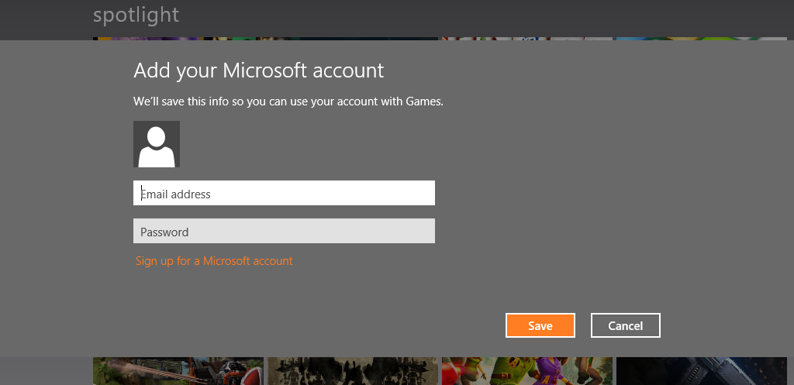

Figure : Sign in with your Microsoft Account

When scrolling left from the Spotlight, the first section that you see, called **Friends**, shows a small selection of your Xbox Live friends. You'll be a will to see their Gamertag, what they're currently playing, how long they've been off-line, and their avatar.

Selecting a friend will show information like their Gamerscore and their Motto, as well as links to comparing your achievements with them, view their profile, or remove them as an Xbox live. Selecting friends at the top will take you to your full friends list, which is where you can see the rest of your friends if they did not all fixed on the home screen. You can use this to add additional friends, or use the pending section to do you any outstanding requests for Xbox live friends.

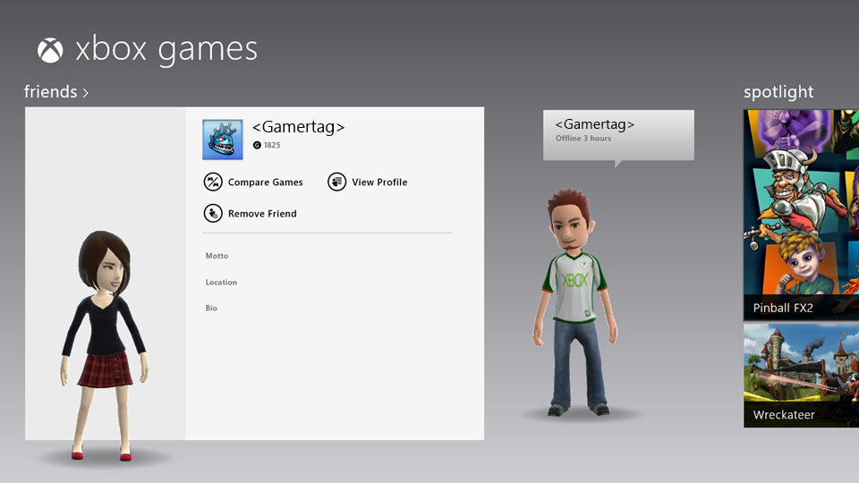

Figure : Xbox Live Friends

Scrolling all the way to the left end of the home screen will take you to a section focused on your Gamertag. Here you will see your avatar, your gamer pic, your Gamertag and Gamerscore, as well as several different actions that you can take against your account.

* Customize your avatar
* Edit profile
* View your achievements
* Share your profile with a friend

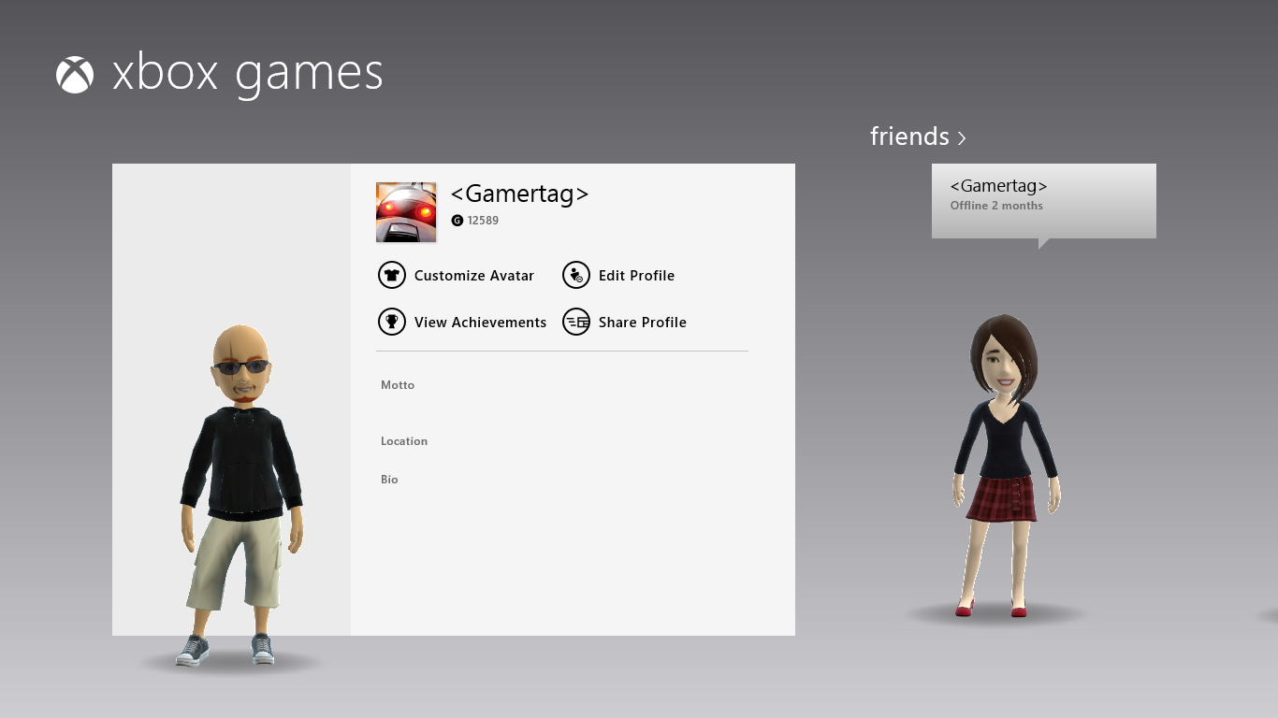

Figure : Your Xbox Live account

### Settings

The **Settings** Charm provides two different sections that could be useful when you're providing support: **Account** and **Preferences**.

**Account** - From the Account section of Settings you will be able to see numerous details related to your Xbox Live account

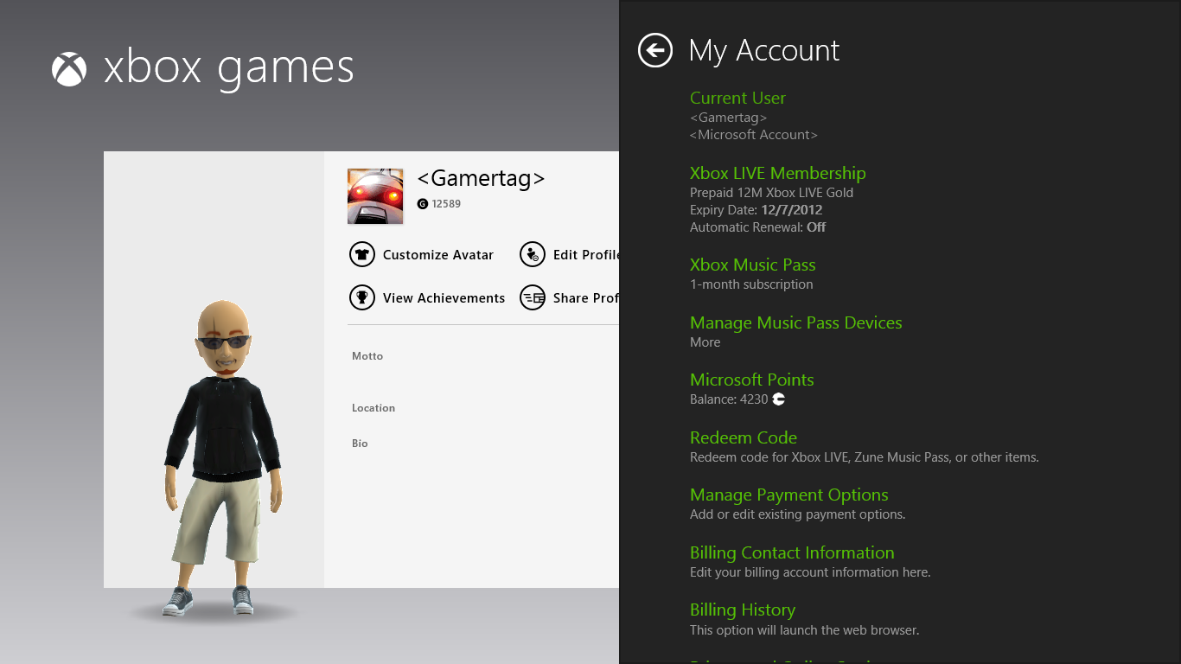

Figure : My Account

* Your Gamertag and the Microsoft Account that it is associated with
* Xbox Live membership details
* Xbox Music Pass details
* Microsoft Points
* Billing and payment options

Almost all questions about any of these options will have to be redirected to the Xbox support group. Supporting any issues related to these concepts requires a set of tools that only they have access to. Information will be provided at a later date as to how to properly redirect issues over to Xbox support.

**Preference** - The preference section is used to switch between users, Microsoft accounts, and also to configure whether or not you will need to provide your account credentials again before making a purchase or doing anything to manage your account.

* If you are using a Connected Account, you will be unable to switch between accounts.

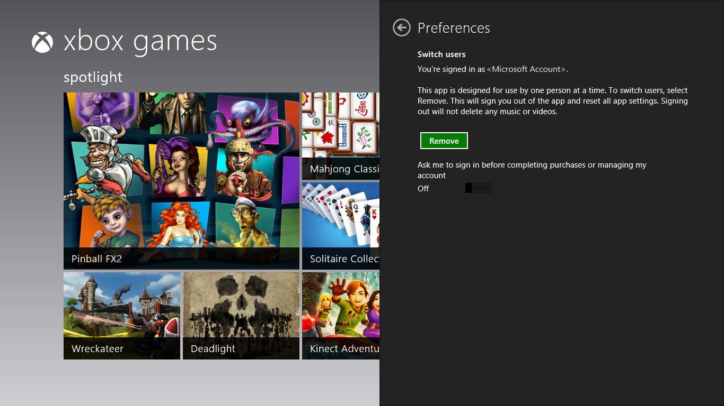

Figure : Preferences

### Try This: Xbox Games

* Find a trailer for an Xbox Live Arcade game.
* Sign into the Games app with a Microsoft Account that does not currently have a Gamertag associated with it.
  + What is the Gamertag that your account was assigned?
* Use the Windows Games Store to download, install, and open the game Solitaire Collection.
  + Start a game of Klondike. What happens after you move the first card?

## Music and Video

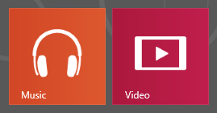

Figure : Music and Video tiles

The Music and Video apps are a great way to access the Xbox Music and Xbox Video Marketplaces, as well as providing a touch friendly experience for your local media. These apps also allow you to play media on the Xbox 360® and use the touch interface to navigate the Xbox 360 dashboard.

**Note:** The Xbox Marketplace was formerly known as the Zune® Marketplace.

Basic concepts about Xbox and Xbox-like Gamerscores and Microsoft Points are out of the scope of this training. All support issues related to your Microsoft or Xbox Live accounts should go to the related support team.

The Music and Video apps bring Xbox Marketplace to the new Windows Experience. The interface for the Xbox apps is very similar to the dashboard on the Xbox 360, since they share the same Microsoft design principles. Content is separated into sections consisting of dynamic tiles that show different artists or movies, and selecting a tile takes you to another interface where you can find more information about that artist or show.

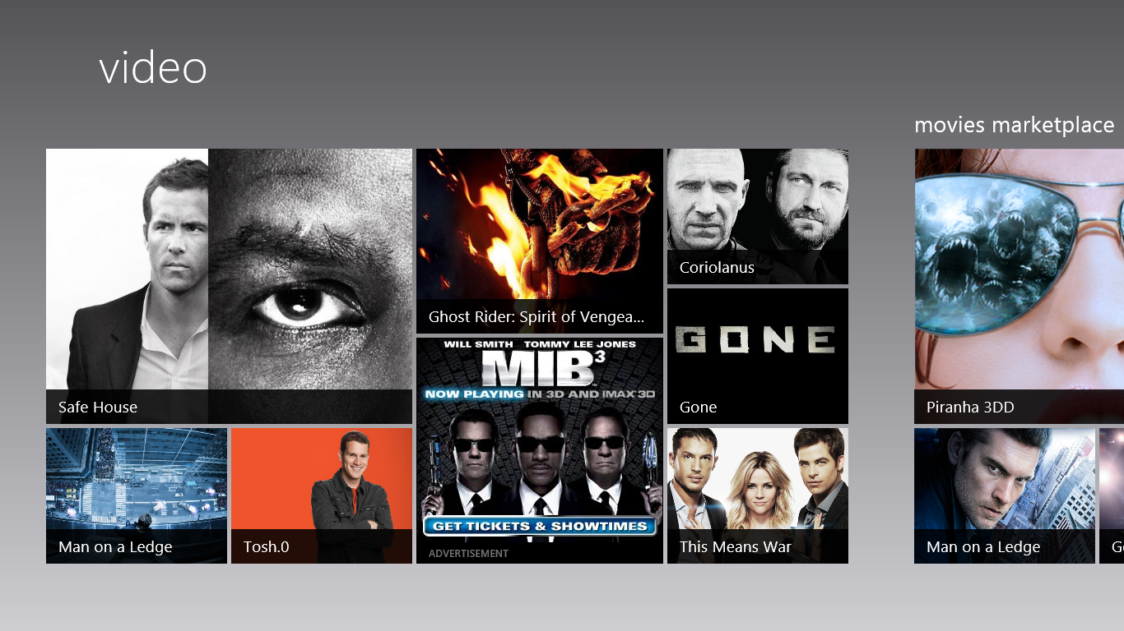

Figure : Video app

Browsing the Music, Movies, or TV Marketplace provides a similar tiled interface where you can browse for media by category, such as like genre or artist.

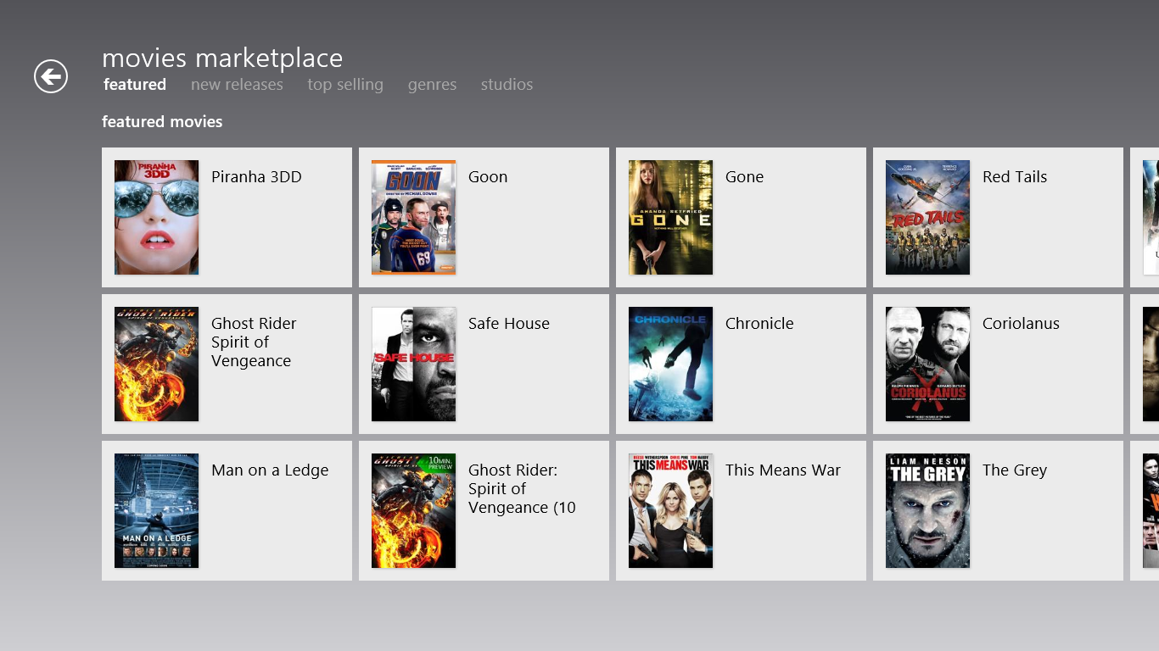

Figure : Browse by categories

You can also use the Search charm to search for specific media in the Xbox Music or Video Marketplace.

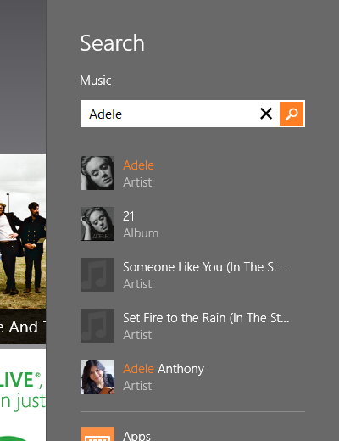

Figure : Search using the Search charm

After you select an album in the Music Marketplace, you are given several options:

* You can play a 30-second preview of all the tracks on the album.
* You can open the artist details page.
* You can also tell the music to play on your Xbox 360.
* You can buy the album or just a specific track using Microsoft points.
* If you have a Zune Music Pass, options to purchase and preview music will be replaced with options to **Play the music** or **Add it to your library**.

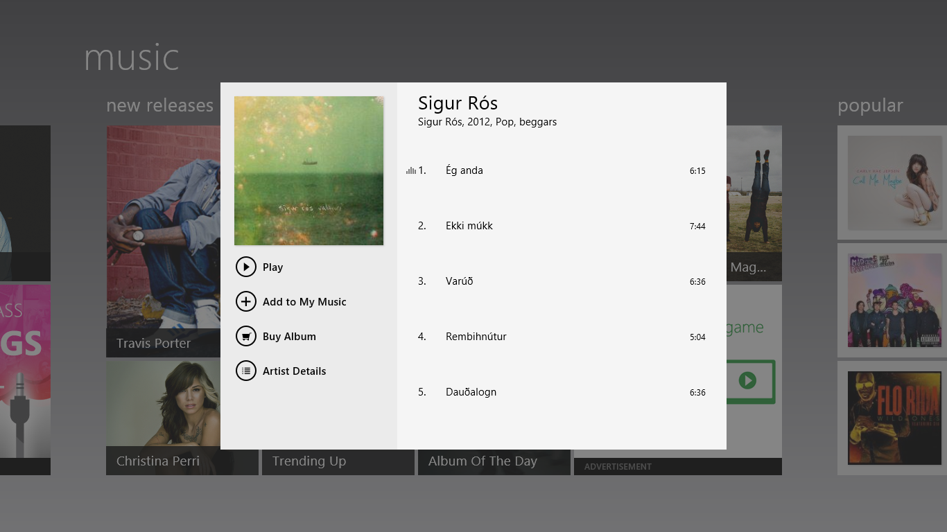

Figure : Playing an album in Music

In the Music app, selecting the **Artist details** button will take you to their page where you can see things like their biography and discography (or list of all the albums that the artist has released).

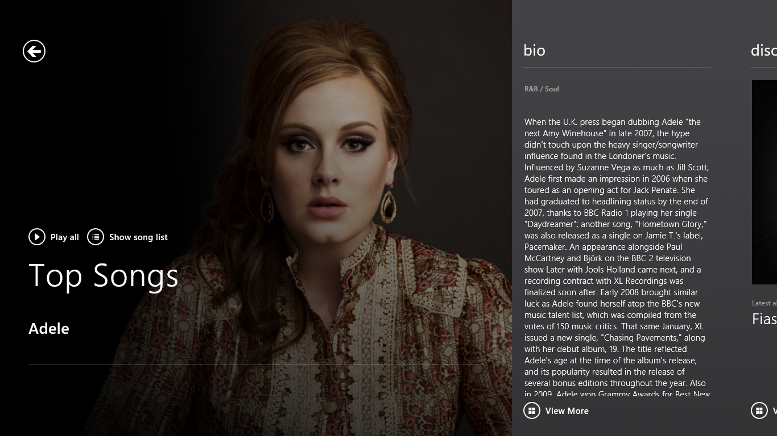

Figure : Artist details

When you browse the TV or Movie Marketplace, you are able to browse by things like show title and the network that the show originally aired on. Similar to the artist page, each series in the TV Marketplace has a series page with a description of the show and a link to view all of this seasons that are available in the Xbox Marketplace.

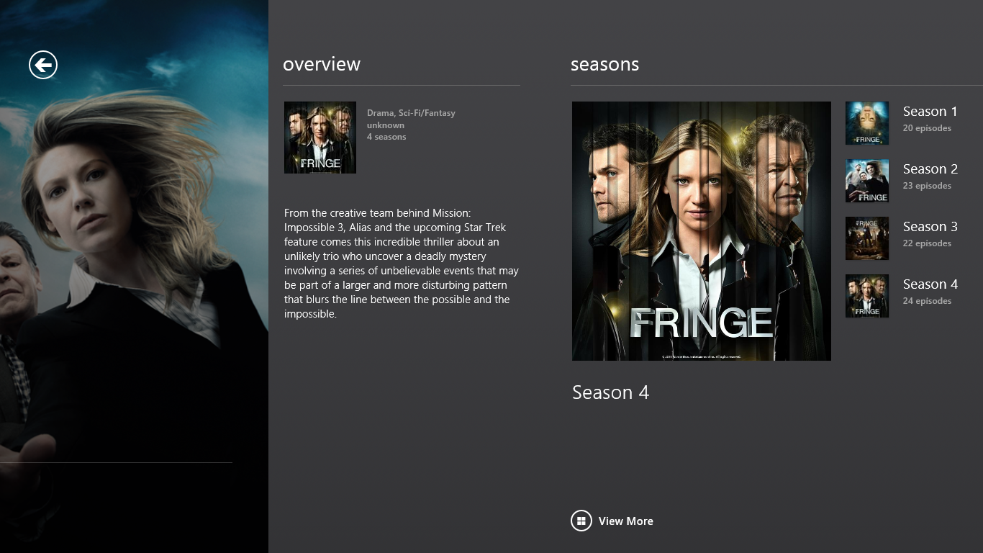

Figure : TV series details

After you select a movie or TV show, you will see options for buying or renting the show, as well as options to play the show on your Xbox 360.

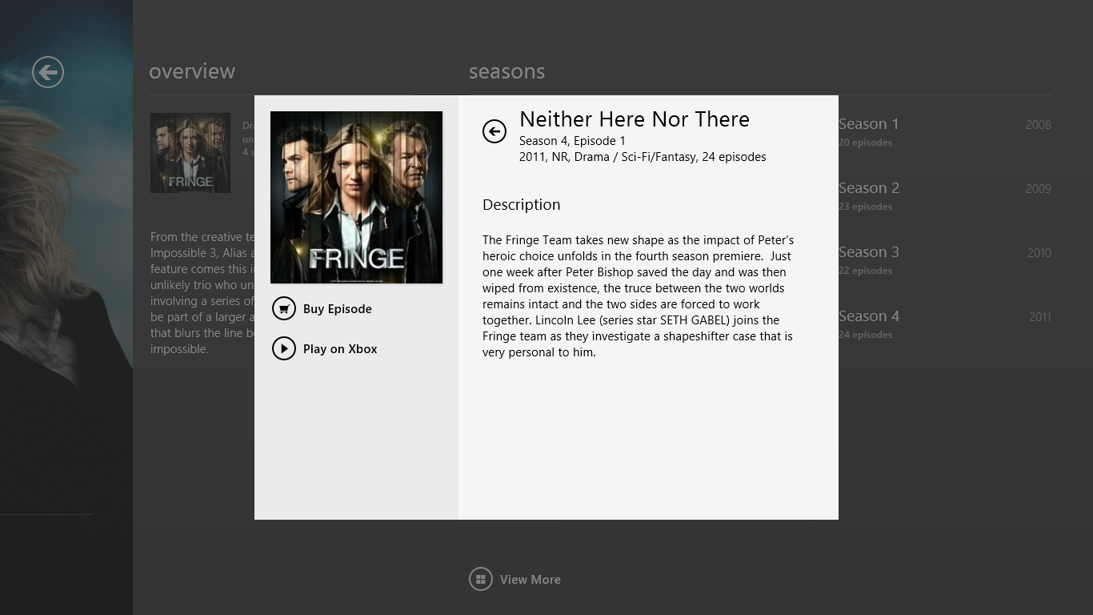

Figure : Episode details

The Play on Xbox option gives you the ability to play media on your Xbox 360 directly. When you select the **Play on Xbox** button, the app will tell the Xbox 360 to stream that media from the Xbox Video Marketplace.

Media that you purchased using the Music or Video apps will automatically be downloaded to your music or video library. These libraries can be seen in Windows Explorer and, by default, consist of two folders:

* The music or video folder in your user profile.
* The music or video folder in the public user profile.

These libraries are also where the Music and Video apps will find and index your local media. Any music or video files that it finds there will be added to the collection you see in the Xbox app. The Music app will automatically obtain metadata for your music from the Xbox Marketplace. The Xbox app will enhance the view of your collection of music by including links to artist information on the Xbox Marketplace site, including details like artist photos and biographies.

**Note:** Existing metadata within the media files will not be used in the Xbox apps.

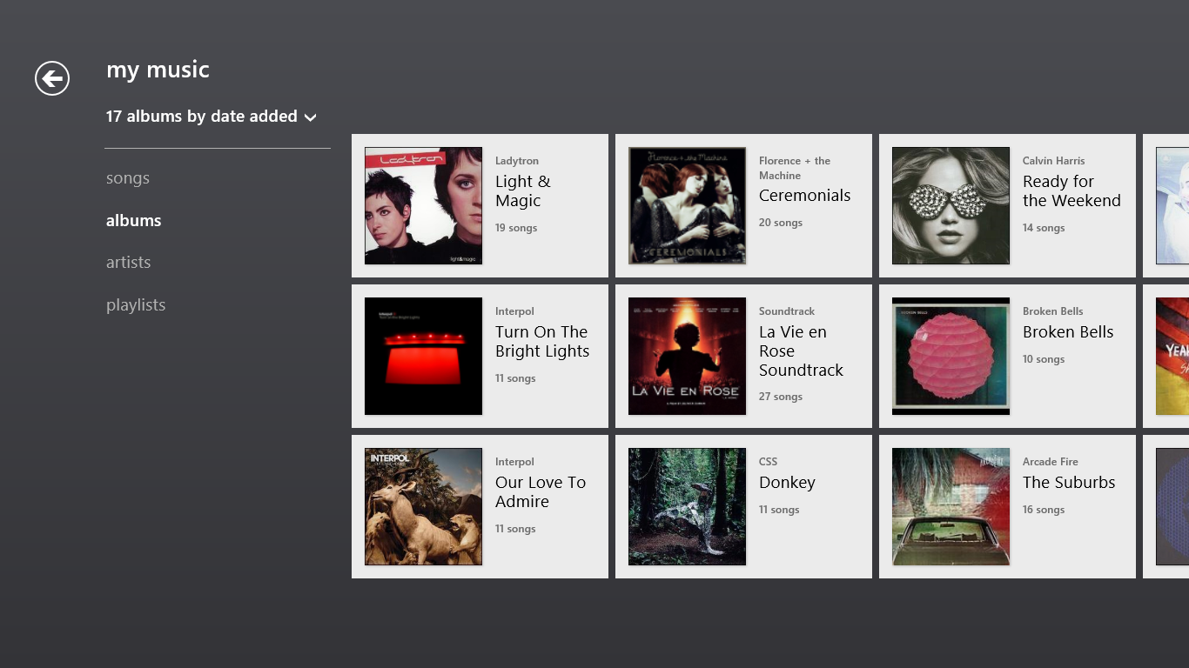

Figure : My Music

After you begin playing music, the app commands will appear with transport controls for the media and information about the currently playing song.



Figure : Music app commands

Tapping the song information in the middle of the app commands will take you to the Now Playing screen. This will display a collage of thumbnails for other artists and albums within your music collection, as well as from the Xbox Marketplace.

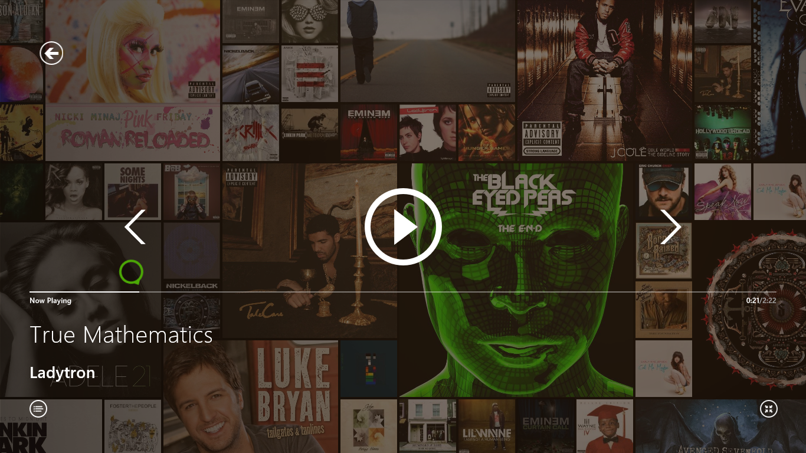

Figure : Now playing

### Adding Additional Music

If you are storing your media in a location outside of the music or video library, you can add that location to the appropriate library so that the Xbox app will know to look in that other folder or network share for your music. You can add additional locations to your music or video library by opening the properties for that library in Windows Explorer on the desktop. After you add the new location, the Xbox app will then index that new location, as well.

You can also add locations to the library using the **Include in library** option on the Windows Explorer shortcut menu.

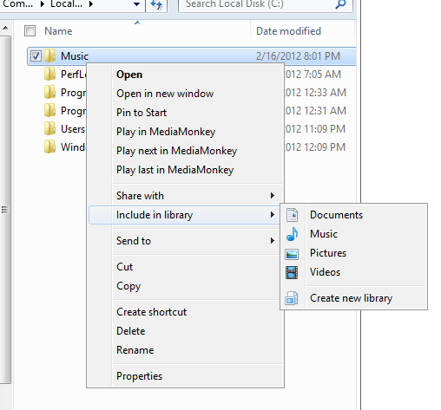

Figure :Add additional locations to a library

After you add the location to the library, it will appear as a folder in the library in Windows Explorer, as well as in the properties for that library.

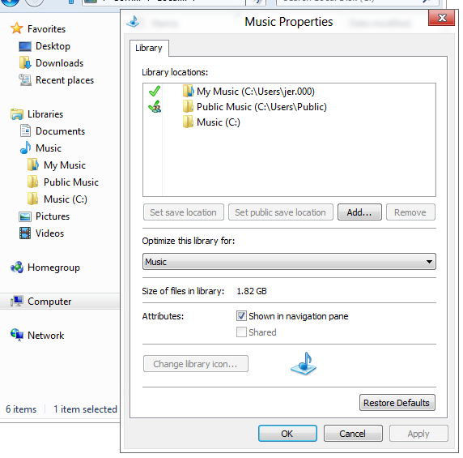

Figure : Library properties

### Settings

Like other Windows Store apps, the settings for the Xbox apps are accessible through the Settings charm. You can view information about your Microsoft account, Xbox Live membership, and Microsoft Points from the My Account section of Settings. Please note that all issues related to Xbox and Xbox Live accounts, including questions about anything that you see under the My Account section of Settings will need to be redirected to Xbox support.

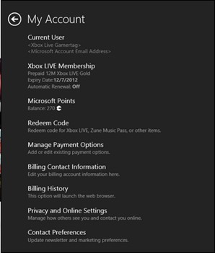

Figure : My Account section

### Try This: Music and Video

* Find the biography and discography for your favorite artist in the Music app.
* Find out how many seasons are available for a TV show, such as *Heroes*, in the Videos app.

## Bing Apps

The Bing team at Microsoft has created several Windows Store apps that provide great ways to interact with many of the various Bing services. The Bing apps discussed are Bing, News, Weather, Maps. Travel, Finance, and Sports.

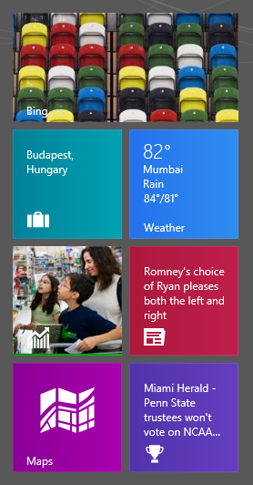

Figure : Bing app tiles

### Bing App

The Bing app provides a modern app experience for searching Bing.com. Many of the same features that make Bing.com unique are reflected in the Bing app, in addition to providing support for Windows 8 specific features like the Share and Search charms.

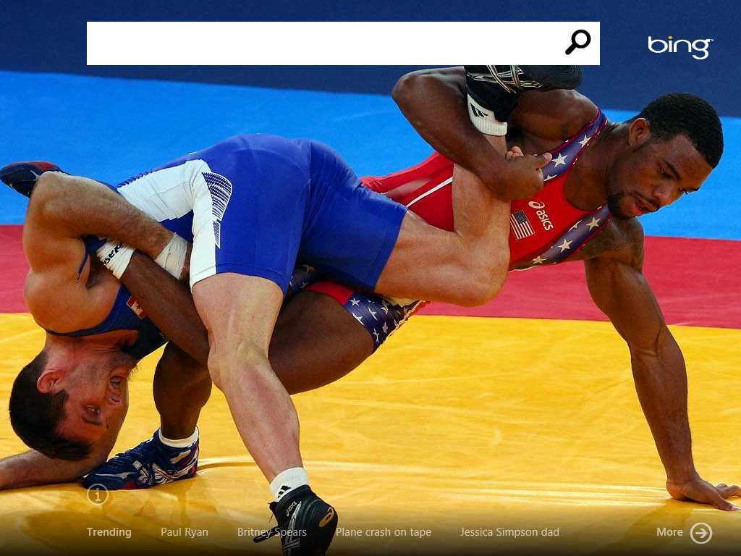

Figure : Bing app

Initiating in a search in the app displays the results in a tiled interface, and selecting any of those tiles will switch to your default browser and open the link.

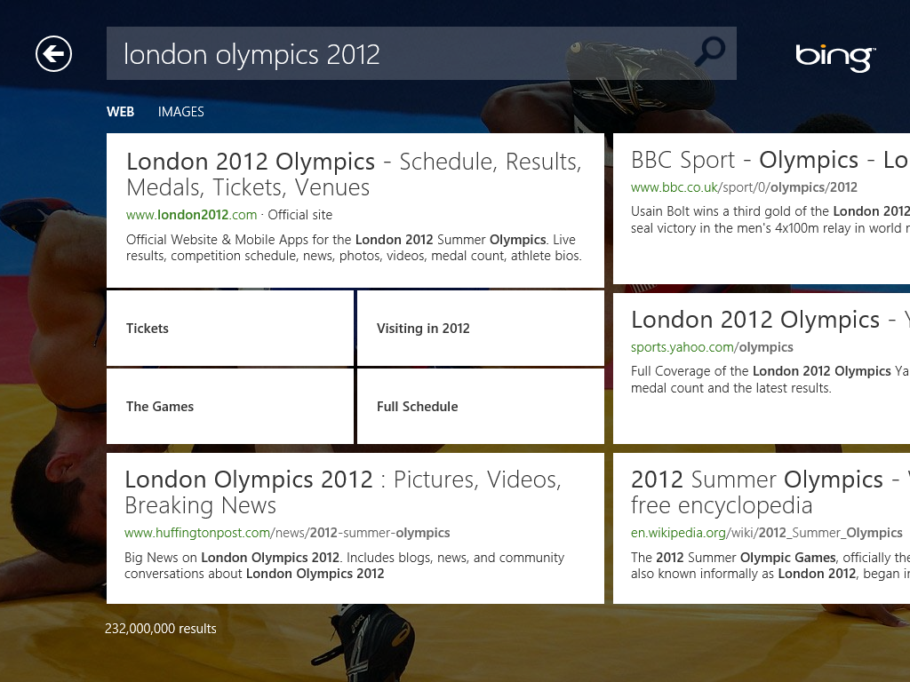

Figure : Search Results

The iconic background that is displayed on Bing.com is also present in the app, along with the contextual squares that appear over the image providing a way to get more information about what is going on. Similar to Bing.com, tapping or hovering your mouse over the image reveals these squares.



Figure : Contextual squares over image

Tapping any one of them provides additional info along with a link to you can click to go find out more.



Figure : Selecting a square shows more information

Just like Bing.com, the information button will also tell you information about the specific picture.



Figure : Information button

We also display trending topics along the bottom to show what the most popular searches across Bing at the moment. Clicking on a trending term will initiate a search for that term as if it had been typed into the search bar.



Figure : Trending searches

Clicking **More** on the bottom right will display additional topics that are currently trending on Bing in a tiled interface similar to the search results.

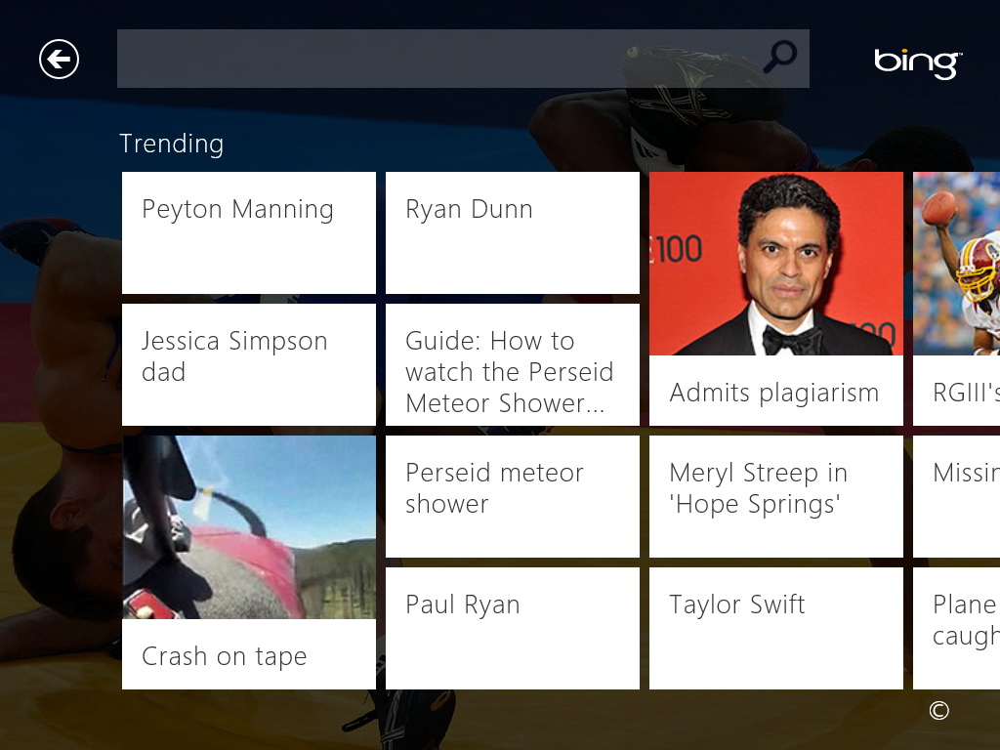

Figure : More Trending searches

In addition to providing some of the most popular experiences from Bing.com, the Bing app also integrates into Windows 8 through features like the Share, Search, and Settings charms.

Table : Bing and charms

|  |  |  |
| --- | --- | --- |
| From within the Bing app you can use the **Share** charm to share the results of a search. | From anywhere in Windows 8, you can use the **Search** charm to initiate a search through the Bing app. | You can also use the **Settings** charm to do things like configure SafeSearch or clear your search history. |
| Figure : Bing and the Share Charm | Figure : Bing and the Search Charm | Figure : Bing and the Setting Charm |

Just like all of the other apps from the Bing team that we will discuss here, the Bing app supports Live Tiles as well.

|  |  |
| --- | --- |
| Figure : Trending searches | Figure : Picture of the day |

### News

The News app provides news gathered from a variety of sources across the web, in much the same way that Bing News on the web does. News stories are grouped into categories such as World News, Business, and Technology on the home screen, and selecting any of those categories will display stories from that category in a separate page. Selecting a story from these areas will open the story and display it in the new Windows UI.

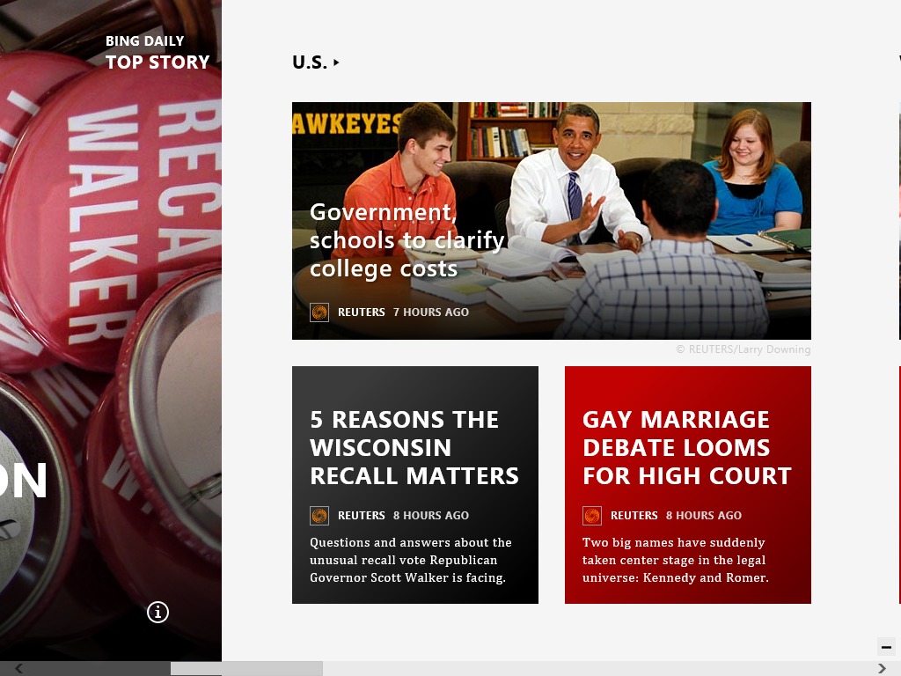

Figure : News app

In addition to the home screen and categories, additional areas are included that allow you to customize the experience and find the news you are most interested in. You can quickly switch between these different areas by using the app commands.



Figure : News app commands

* **Bing Daily**. This is the home screen for the app and will be the first area that you see when you open it.
* **My News**. From this screen, you can add topics or events that you are interested in, and the News app will display articles specifically related to those topics.
* **Trends**. This area shows the most popular stories that are happening today, and provides several articles related to that story. Just as you could with Bing Daily, you can select the section header view only articles about that topic.
* **Sources**. From this area, you can select from hundreds of different news sites, and view only the article from that specific site.

#### App Details

* You can pin any of the news categories to the Start screen as secondary tiles so that you can see what is happening in the world without needing to explicitly open the News app.
* You can also pin custom sections from My News to the Start screen.
* News articles in the My News, Trends, and Sources sections will display the original webpage as opposed to the new Windows UI formatting of Bing Daily.
* You can use the Settings charm to change the language that content is displayed in and clear your search history.

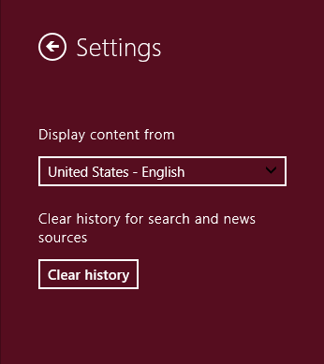

Figure : News settings

### Sports

The Sports app provides news and information about sports in general and your favorite teams. The layout is very similar to the News app, though in addition to showing news articles about sports, it also shows information like leaderboards, scores and game outcomes, as well as information about individual players.

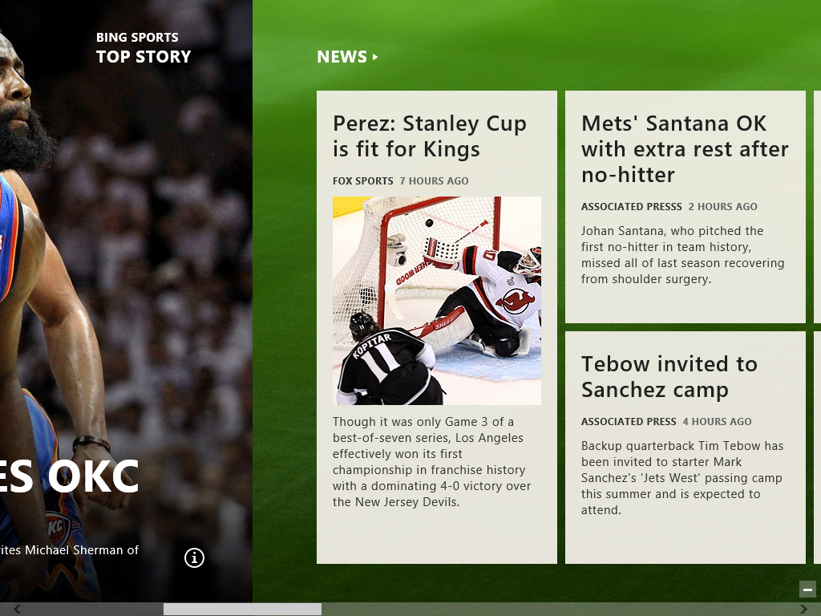

Figure : Sports app

This app has several different areas that are accessible through the app commands, with the majority of them focused on providing information about specific sports.

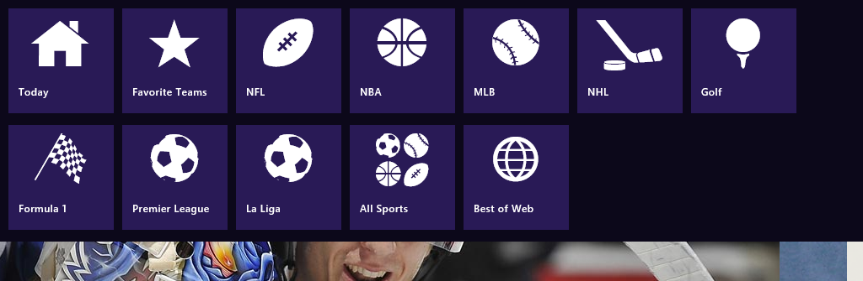

Figure : Sports app commands

* **Today**. This is the home screen for the app, and is where the biggest stories of the day are displayed, along with the schedule and scores for any games that are playing today.
* **Favorite Teams**. Here you can keep track of what’s happening with your favorite teams. You can add your teams to this list, and selecting any of them will display news, current stats, and information about the players on that team.
* **League buttons**. There are several league buttons that will each take you to an area that provides specific information about that league or sport.
* **All sports**. This view lets you select from a list of all the sports and leagues that the Sports app supports. This controls the leagues that are displayed in the app commands and in the sports schedule on the home screen.
* **Best of Web**. This area provides links to the best web sites for sports coverage, divided into sections like News and Rumors, Olympics, and Recruiting. These sections contain links to several sites that focus on news related to that section. Selecting one of these links opens the page in Internet Explorer®.

#### App Details

* You can pin individual leagues and sports to the Start screen.
* The Settings charm defines how often information on things like sports scores is updated from the web and what language to display information in.

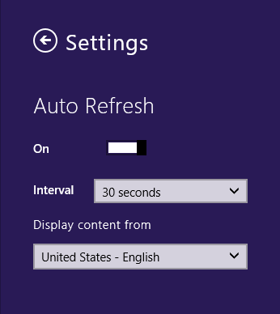

Figure : Sports settings

### Maps

The Maps app provides a touch-centric interface for Bing Maps on a PC running Windows 8. This includes key features of Bing Maps, such as driving directions, traffic and aerial view.

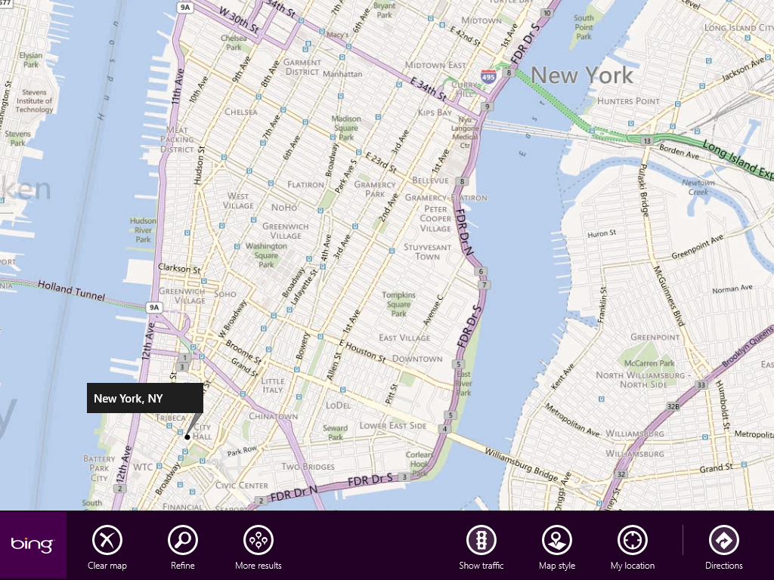

Figure : Maps app

In the Maps app, the app commands at the bottom can be used to switch between different areas in the app:

* **My Location -** Uses location data to show your current location. To enable or disable location data usage, open the Settings charm.
* **Show traffic -** Shows traffic flow colors on the map.
* **Map style -** Use this to change between road view and aerial view.

You may also see these commands, depending on the current context:

* **Clear map -** Shown during a search or while viewing directions. This clears the search or directions, giving you a clear map view.
* **More results -** This appears when you are doing a search so that you can see additional results.
* **Refine -** Allows you to search to provide additional details about the location you are looking for in a given area.
* **Directions -** This option appears when you are doing a search, so that you can get directions to or from the location of the search.

**Note:** There is not a dedicated search field within this app. If you need to search for a particular location, you can use the Search charm.

### Weather

The Weather app is a Windows Store app from Bing for viewing weather information, focused on weather in your location. From the home screen, you can swipe or scroll to view additional information about the city you are viewing, such as the hourly forecast, weather maps, and historical weather data.

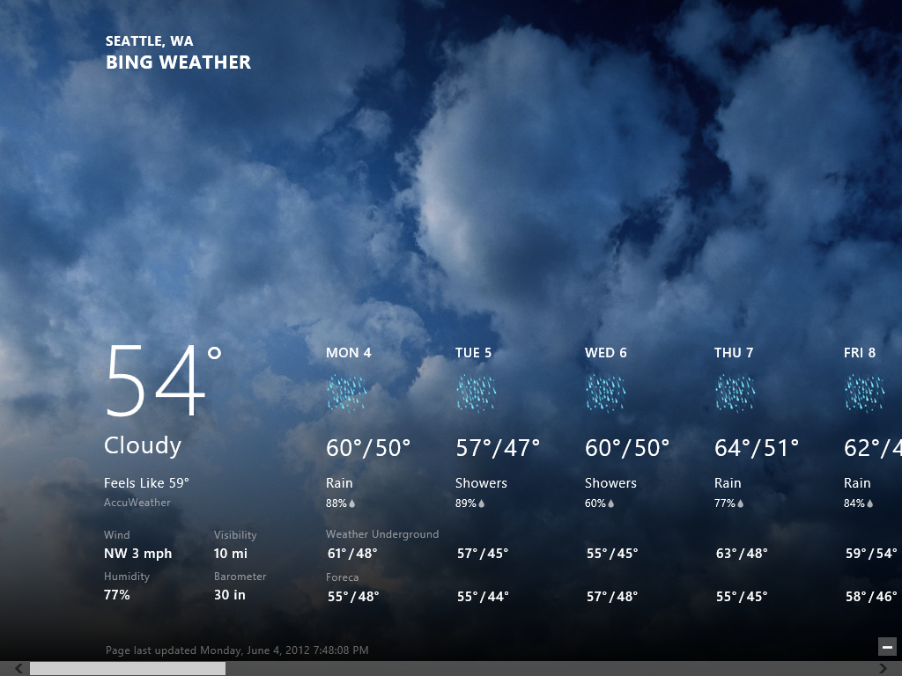

Figure : Weather app

When you swipe up from the bottom or right-click, a bar will open at the top and bottom of the screen. The bar at the top contains the following app commands:

* **Home -** Go to the main page which displays weather information about the first city that is configured.
* **Places -** View and change the places in your favorites. This allows you to add additional cities that you would like to try the weather for.
* **World weather -** See an overview of weather conditions around the world.

The bar at the bottom allows you to switch the temperature units from Fahrenheit to Celsius or vice versa and also refresh the current view. You can also switch these temperature units from the Settings charm, where you can also configure your Search History.

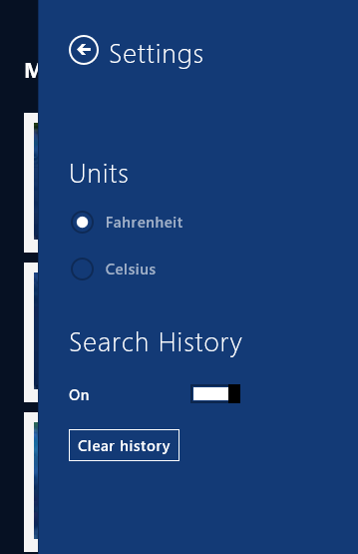

Figure : Weather app settings

#### Places

The Places page is where you can add or remove locations, set your default location, and view a summary of weather in all your locations.

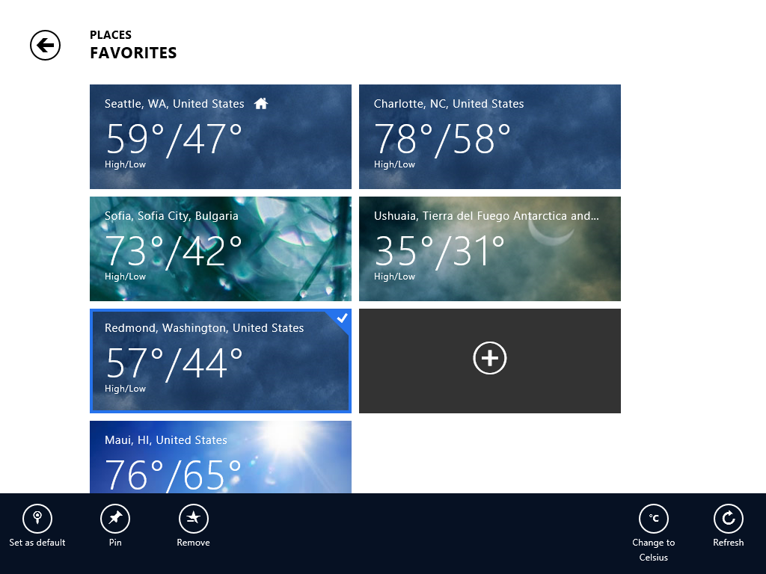

Figure : Places in Weather app

When you select a place, you can set it as the default, pin it to the Start screen, or remove it from your favorites. Pinning to the Start screen enables you to quickly see the weather in another place at a glance without ever opening the Weather app.

### Travel

Travel is an extraordinarily rich app for finding vacation spots and information about flights and hotels at your destination. You can use this app to plan and book your vacation from start to finish, and then you can use it to find out what to see and do once you are there.

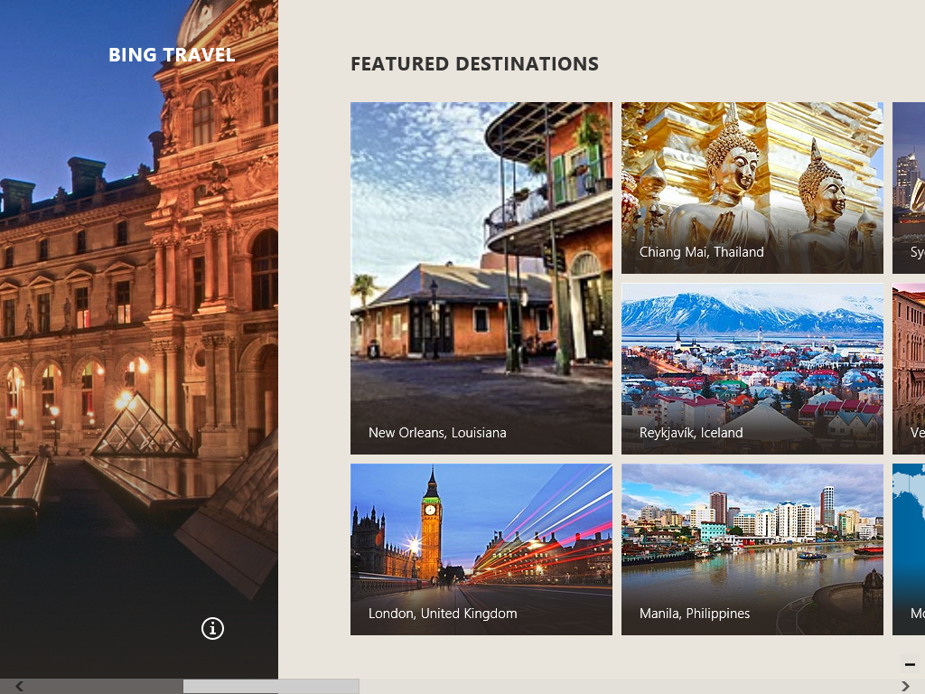

Figure : Travel app

The Travel app includes several tools to help you find great places to go and plan the trip once you decide on your destination:

* **Destinations -** Both the **Destinations** link and Featured Destinations section on the home screen take you to a page that provides a wealth of information about that specific destination:
  + Reviews with large lists of things to see and do from trusted travel resources like Frommer’s, which includes resources like travel guides, restaurant and hotel reviews, and other useful information about your destination.
  + Maps, currency conversion, and weather information about the location.
  + Photos and 360-degree panoramas of popular attractions.
* **Articles -** The articles section on the home screen provides articles and reviews from many great travel oriented sites on the web
* **Flights and Hotels -** Both of these are app commands for the app, and they provide a great way to find out flight information and places to stay once you get there:
  + The Flight tool lets you search for flight, look up flight schedules, and find out the status of a particular flight, as well as providing 360 degree panoramas of many popular airports.

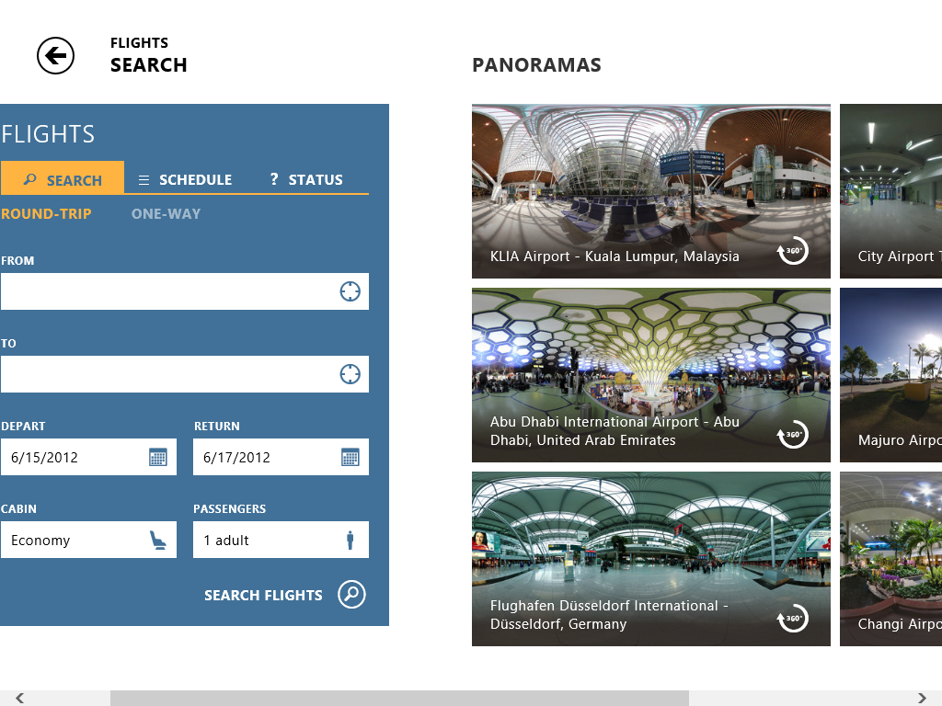

Figure : Flight tool

* + The Hotel tool lets you search for hotels at your destination, letting you filter based on price, class, and amenities. Additional information is provided for each hotel including a description, maps to the hotel and photos of the hotel.

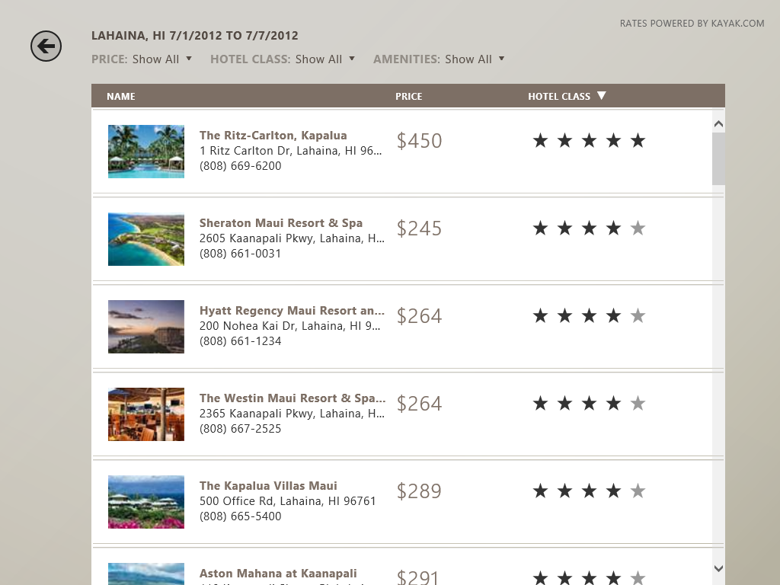

Figure : Hotel search

* Booking flights or hotels will open a third-party site that will automatically take you to the flight or hotel that you selected in the Travel app.

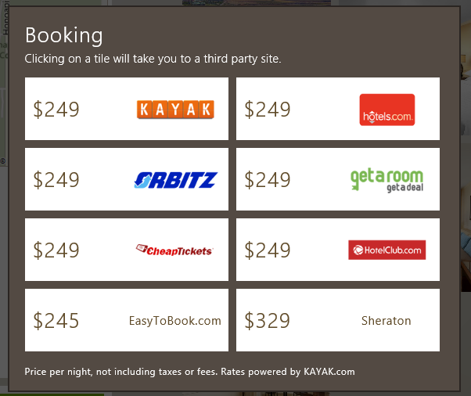

Figure : Booking a trip

* **Best of Web –** Also available as an app command from the top of the screen, this area shows you many of the great travel web sites available all over the web.

### Finance

The Finance app provides information and news related to business and the stock market. Data in the app is updated automatically―with a 15-minute delay for securities quotes, and a 30-minute delay for quotes shown on the tile on the Start screen.

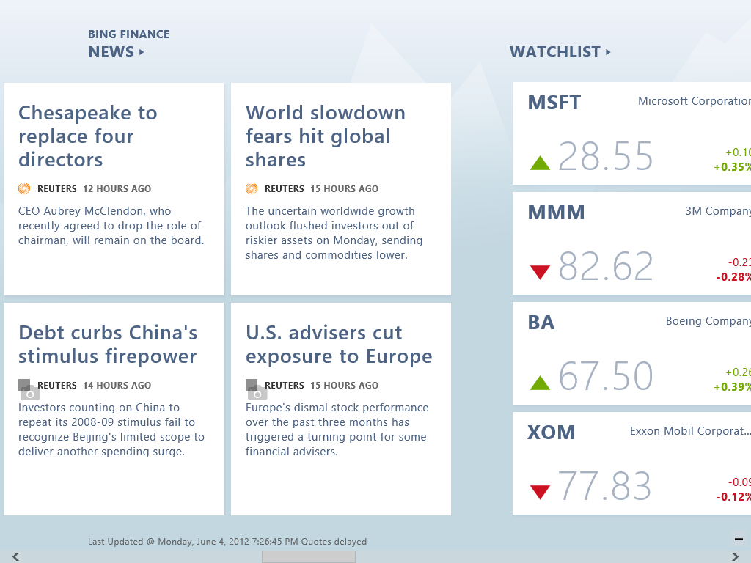

Figure : Finance app

The app commands at the top of the screen can be used to switch between the different areas of the app, which are described below:

* **Today -** Takes you to the main page, showing top stories, your watch list stocks, market indices and top movers. To avoid showing penny stocks, top movers are only shown for stocks with a market capitalization of $100 million or greater.
* **Watchlist -** Takes you to the list of stocks in your list.
* **News -** Takes you to a page with business-related news stories.
* **Rates -** Takes you to a page with mortgage, savings, credit card, and other rates.
* **Currencies -** Takes you to a page that shows the current exchange rate for various currencies. This page also includes a currency converter.
* **World Market -** Takes you to a page that displays the current rates for stock indexes around the world.
* **Best of Web -** Takes you to a page with finance related stories from other sites on the Internet.

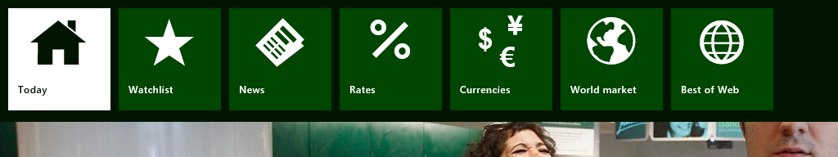

Figure : Finance app commands

The app provides information on stocks, exchange-traded funds and mutual funds. You can view a quote by from the Search charm.

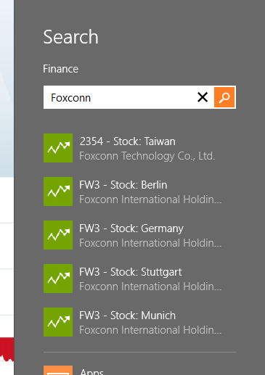

Figure : Finance search

#### Watchlist

Up to eight stocks from your Watchlist are shown on the Today page. If you have more than eight stocks in your Watchlist, select the Watchlist from the app commands to see all of your stocks.

To add stocks to your Watchlist, go to the Watchlist page and click the plus “+” symbol.

Removing stocks is done by tapping and holding (or right-clicking) a stock tile and swiping down. A check mark will appear in the upper right corner of the tile. Tap the **Remove** button at the lower left of the screen.

You can also pin items from your watchlist to the Start screen.

### Try This: Using Bing Apps

* Use the Finance app to get a stock quote for a stock not in your watchlist.
* Check on the latest home equity loan rates in the Finance app.
* Get directions to the nearest Microsoft Store using the Maps app.
* Add a few places in the Weather app.

## Communications Apps

The Communications apps are a set of four apps included with Windows 8 designed to enable you to keep track of your life and interact with the people in your life. The four apps that make up the Communications Apps are Mail, Calendar, People and Messaging. These apps are not meant to be exactly like the service or essentials offerings, so they shouldn’t be compared that way. These apps focus on providing the best expression of these services as experienced through the new Windows UI.

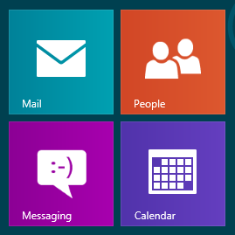

Figure : Communications apps

The Communications apps are distributed together in a single app package. What this means is that **Mail, Calendar, Messaging**, and **People** are all listed on the same product description page in the **Windows Store**, and they are installed, uninstalled and updated as one. The Communications Apps are the only apps that will be allowed to do this in the Window Store.

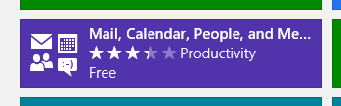

Figure : Communications apps in the Windows Store

By being distributed it as a single app package, these four apps are also able to share their settings between each other. If you configure an email or social networking service in any one of these apps, that service will then be available to all four of your apps. For example, configuring your **Hotmail** account in the **Mail** app will also do the following:

* Your **Windows Live Calendar** will be configured in the **Calendar** app
* The **Messaging** app will be configured to use the **Windows Live Messenger** service
* The **People** app will be able to access your **Windows Live Contacts**.

#### Microsoft Account

In order to use any of the Communications apps, you will first need to sign in with a **Microsoft Account**.

* If you are using a Connected Account, you will be automatically signed in using that account.
* If you are using a local account, you'll be prompted to enter the credentials for your Microsoft account or sign up for one.

Additionally, when you configure a social networking service like Facebook or Twitter in one of the Communications apps, those social networks will then be associated with your Microsoft Account. This means that the next time you sign in on another Windows 8 PC with the same Microsoft account, those social networks will be automatically configured.

If you are using a Connected Account in Windows 8, any services that you configure there will automatically be roamed to every other Windows 8 PC that you sign into with the same Microsoft Account.

#### Configuring Accounts

The process for viewing and configuring accounts in one of the Communications apps will be same for all four apps. You simply need to go into the Settings charm and from there select Accounts.

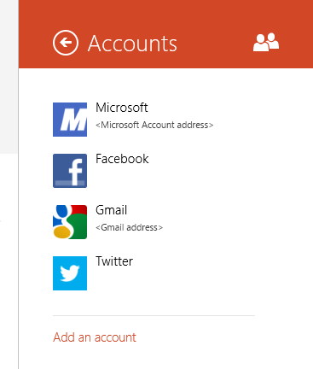 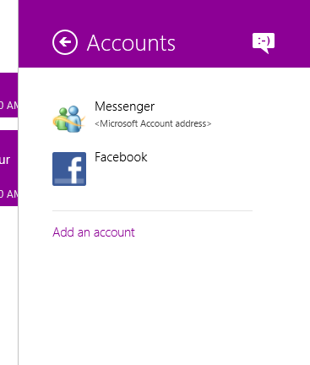

Figure : Accounts in Settings

This pane will show you all of the accounts that the app is currently configured to use. As you can see in the screen shots above, we have a Microsoft Account configured, along with Gmail, Facebook, and Twitter account. Selecting any one of those accounts will take me into the settings for that particular account. For example, if I were in Mail, I could change the settings for the server I am connecting too from Accounts in the Settings Charm and selecting the mail provider.

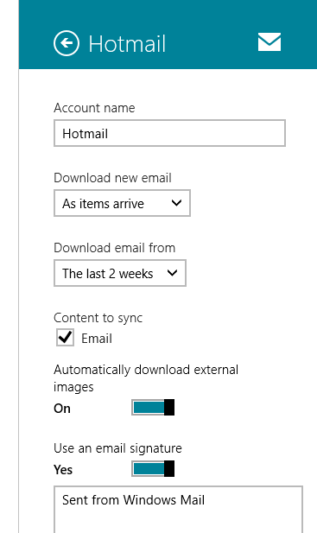

Figure : Account settings for a mail account

Next, all four apps will be able to configure a new account by selecting the **Add an account** link in the Accounts section of the Settings Charm

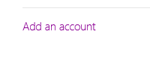

Figure : Add an account link

From here you can see a list of all of the different account types that are supported in a given app.

**Note:** Some apps only allow one instance of a given service to be configured, so once it is setup the service will no longer be visible in the list under **Add an account**. We can see this in the screen shot for the Messaging app below. Messaging supports Windows Live Messenger and Facebook, but both are configured so they do not appear in the **Add an account** pane.

Table : Add an account

|  |  |  |  |
| --- | --- | --- | --- |
| **Mail** | **Calendar** | **Messaging** | **People** |
| Figure : Mail | Figure : Calendar | Figure : Messaging | Figure : People |

For People, Messaging, and Calendar, the services that are listed under the **Add an account** pane are the only services that the app supports. The Mail app is the exception since it provides the ability to connect to an arbitrary IMAP or EAS (Exchange ActiveSync) server by using the **Other Account** option

You may be asked if any of these apps support additional providers other than what is available in the box. The only providers that are supported are those that are currently listed. Microsoft has worked hard to help ensure a positive experience with these specific services and in many cases the app is required to understand the specific API set exposed by the service, which is not something that can be added by an end user. If you have suggestions about additional providers that these apps should support in the future, please use the **Feedback** app commands on the bottom of each of these apps, and that feedback will be directed to the Communications app team at Microsoft.

### Mail

The Mail app is a modern email experience for Windows 8 that embodies the Microsoft design principles. It is fast and fluid, works great with touch as well as with a keyboard and mouse, allows you to focus on your content, and provides the right features at the right time. The Mail app is a reimagining of what a great email experience should be.

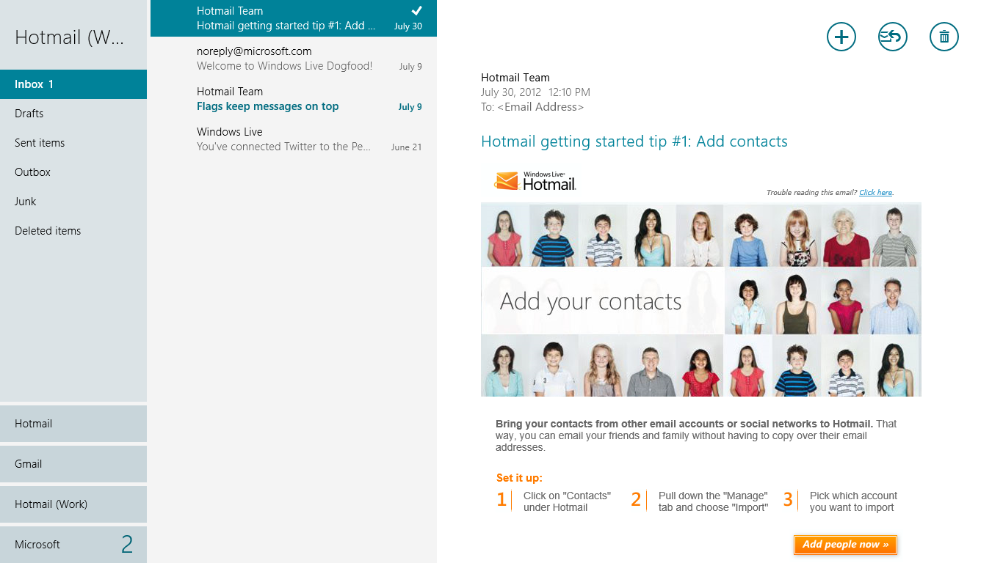

Figure : The Mail app

The design of the Mail app is intended to provide a vastly simplified experience for your email. Extraneous buttons and toolbars have been removed and only the most important aspects of the mail experience are presented to the user.

Despite the simplification of the main interface, the additional options that you normally use in email can still be accessed by opening the Settings charm or by using the app commands. The app commands displayed when you swipe up from the bottom or right-click will change depending on the context of what you are doing at the time. For example, the first screen shot below shows the apps commands you will see when you select one or more emails. Only the actions that are relevant to managing email at the message level are displayed.



Figure : App commands from the home screen

The second screen shot shows the commands you will see when writing an email. As you can see, the majority of these are related to formatting the text of the mail. You will also notice an option here for adding attachments to the mail.



Figure : App commands while writing mail

The layout for Mail consists of three main panes:

* Folder list
* Message list
* Email message

If you have multiple accounts configured, they will appear in the list on the bottom left corner. Selecting a different account will change the folders and messages that are displayed to reflect that particular account.

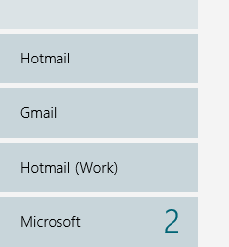

Figure : Account list on bottom left

The interface is not configurable, so the panes cannot be resized and the folder and message lists cannot be hidden. There are two exceptions to this:

* If you have a smaller screen with 4 x 3 aspect ratio (1152x864 or 1024x768), the folder list will not be displayed.
* If you're in portrait mode, only one pane will be displayed.

In both cases, if the folder list is hidden, a back button will be displayed at the top of the message list that will take you to the folder list.

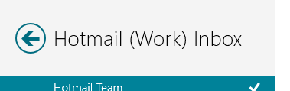

Figure : Back button displayed when view is collapsed to two panes

#### Protocols

Mail supports two protocols when connecting to a mail server: **IMAP** and **Exchange ActiveSync (EAS**). Both of these protocols use a configuration where the primary copy of all your mail is stored on the server. The mail on the client is essentially a cached copy of what is on the server. One benefit of this is that you can configure the same mail account on multiple PCs or devices, and the same view of your mail will be presented at each place. You could lose a device, or uninstall the app, and your mail will continue to exist on the server.

**Note**: POP3 is not currently supported by the Mail app.

* Both protocols supports folders, meaning that any folders you create on the server or from another client will be visible on every other client that connects to that server.
* Both also support working with your mail offline, so that you can delete and read mail while you are disconnected, and once you go back online your changes will sync back up to the server.
* Both protocols have the ability to see new email come in real time, and will immediately download those new messages, as opposed to POP3 where you must periodically poll the server for new messages.

Let's compare these two protocols:

* **IMAP** - IMAP (Internet Message Access Protocol) is an Internet standard protocol that has been around for many years. Many web mail providers and some ISPs support IMAP on their servers, usually in addition to POP3 and a web experience.
  + The IMAP protocol is only used for receiving mail. Clients that use IMAP for mail will send their mail using SMTP.
  + IMAP only supports mail, which means that IMAP cannot be used to sync your calendar or contacts.
* **Exchange ActiveSync (EAS)** - The EAS protocol was created by Microsoft to provide a method for mobile devices to communicate with Exchange Servers. Microsoft licensed this protocol to many third-party mail providers, and we also support it on Hotmail, Outlook.com, and Office 365.
  + Unlike IMAP, which only supports email, EAS supports syncing email, calendar, contacts, and tasks.
  + Because of this and the fact that EAS provides an easy way to connect to their service, this protocol has recently become very popular among web mail providers.

#### Supported email providers

Mail includes support for several of the most popular email providers, including Hotmail and Outlook.com. By having these providers pre-configured, you don't need to worry about things like the server or security settings required to access a particular mail service. Simply select your provider from the list, and sign in when prompted.

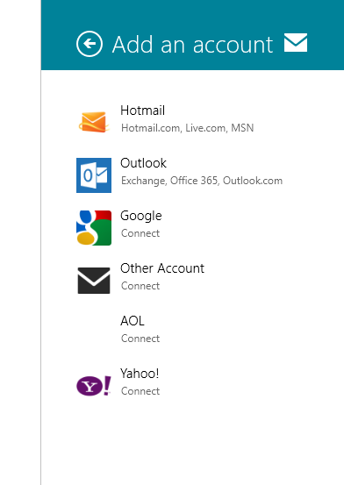

Figure : Supported accounts

The table below lists the services that are currently preconfigured in the Mail app, along with the protocol that they use.

Table : Preconfigured services

|  |  |  |
| --- | --- | --- |
| **Service** | **Protocol** | **Notes** |
| Hotmail | EAS | Includes Hotmail.com, Live.com, MSN |
| Outlook | EAS | Includes Exchange, Office 365, Outlook.com |
| AOL | EAS |  |
| Yahoo | EAS |  |
| Google | IMAP/EAS | Includes Gmail. The note below the table provides more information about which protocol Google will use. |

|  |
| --- |
| **Note**: When configuring a Google Account, you are given the option to **Include your Google contacts and calendars**.   * If you do not check this box, the account will be configured as IMAP. * If you do check this box, the account will be configured as an EAS account.   Machine generated alternative text: Enter the information below to connect to your Google account. Email address Password Include your Google contacts and calendars C77nect Cancel  Figure : Additional checkbox displayed when adding Google accounts |

#### Microsoft Account Required

Before you can use the Mail app with any mail provider, you must first sign in with a Microsoft Account. There is no option to have only your third-party account configured. The first time you open the app, you will be prompted for a Microsoft Account to use with the app. The Mail app will configure that account as your primary Microsoft Account.

**Note**: If you are using a Connected Account, this will be automatic and you will not see any prompts for authentication.

* If the Microsoft Account that you signed in with is an Outlook.com or Hotmail-based account, it will be configured as en email account in Mail, at which point it will just begin to sync your mail.
* If the Microsoft Account that you signed in with uses a third-party email provider that is preconfigured in Mail, you will next be prompted for the password for your email account. Mail will use this to configure the email account and begin syncing email.
* If the Microsoft Account that you signed in with uses a third-party email provider that is not preconfigured, Mail will try to automatically find the settings for that account, and if that fails you will be prompted to configure the account manually, as you can see below.

**Note**: Selecting the option for POP on this screen just displays a message indicating that the protocol is not supported.

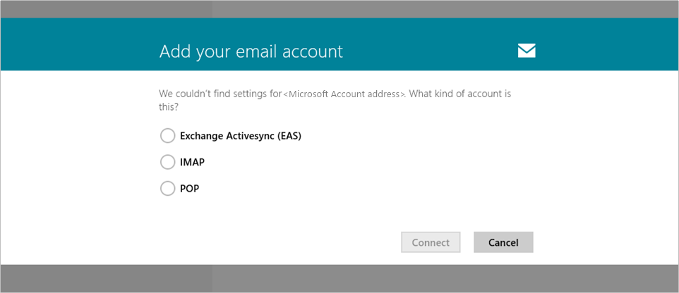

Figure : Mail settings were not found

If you attempt to remove your primary Microsoft Account, all configured email accounts will be removed and the app will display a message indicating that you must sign into with a Microsoft account.

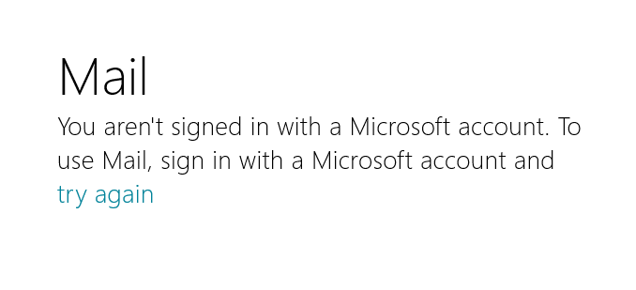

Figure : You are not signed in with a Microsoft account

When you view the settings for the primary Microsoft Account, you will see that the **Remove accounts** button that is present in all of the other accounts is instead a **Remove all accounts** button. There is also a warning, as you can see in the screen shot below.

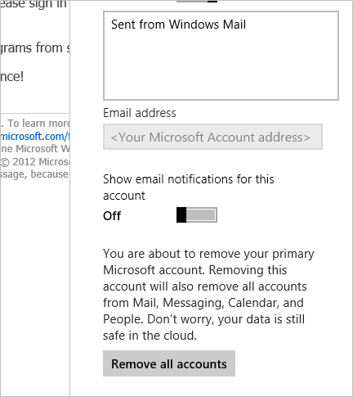

Figure : Remove all accounts button

#### Adding a pre-configured account

The table below describes the steps for setting up one of the preconfigured email account in Mail.

Add a pre-configured account

|  |  |  |
| --- | --- | --- |
| 1. | Open the **Settings Charm.** | |
| 2. | Select **Accounts**, and then **Add an account.** | Figure : Select Add an account |
| 3. | Select your email provider from the list. In this case we will select Hotmail.  **Note**: To manually configure an EAS-based email provider, select Outlook from the list in this pane. | Figure : Select your email provider |
| 4. | You will be prompted to enter your credentials for the service that you selected. Enter your credentials and click **Connect.** | Figure : Enter your account credentials |
| 5. | If your credentials are valid, that dialog will be dismissed and Mail will immediately begin syncing your new account. | Figure : Mail begins syncing immediately |

#### Manually configuring an account

In addition to the preconfigured email providers in the Mail app, you can also manually configure an email provider using IMAP. The table below describes this process.

Table : Manually configuring an account

|  |  |  |
| --- | --- | --- |
| 1. | Open the **Settings Charm.** | |
| 2. | Select **Accounts**, and then **Add an account.** | Figure : Select Add an account |
| 3. | Select **Other Account** from the list. | Figure : Select Other Account |
| 4. | First, you will be prompted to enter your email address and password.  Mail will attempt to automatically discover the server settings for your mail provider. | Figure : Enter your credentials |
| 5. | If Mail is unable to automatically discover the settings for your provider, you will be asked to enter these settings manually, as shown in the screen shot below. | Figure : Manually enter the details for your account |
| 6. | Once you enter your server settings and successfully connect, Mail will immediately begin syncing with the server. | |

#### EAS security

Because the Mail app supports EAS, many users will use the Mail app to connect to their corporate Exchange server. Much of the experience will be the same when connected to a real Exchange server as you might see when connected to a consumer mail service like Hotmail. One key difference, however, is the fact that Exchange has the ability to apply policies to the PC over the EAS protocol that restrict some functionality within Windows.

**Note**: Your PC does not need to be joined to a domain to have these policies applied.

Here are some examples of possible restrictions that may be placed on a PC when connecting to an Exchange Server that is configured to distribute EAS policies.

* A password may be required to sign in to the PC.
* A strong password may be required for your user account.
* The use of PIN or Picture passwords may be disallowed.
* The PC can be forced to prompt for a password when it resumes from sleep.

When you first connect to a server that enforces an EAS policy, you will see a system notification indicating that security policies must be applied to your PC before you can connect to this server. You will need to click **Enforce these policies** to continue.

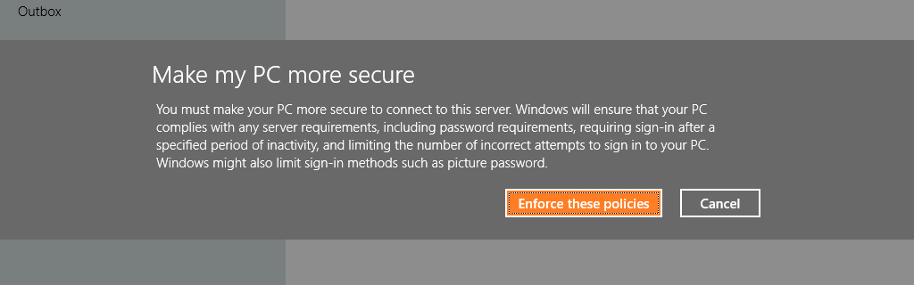

Figure : The Exchange server you are configuring requires EAS policies

After clicking **Enforce these policies**, you are taken to the Mail app and email begins to sync from Exchange. The policies have already been applied, and you can see this by going to the **Users** section of **PC Settings**. In the screen shot below, there are four important things that indicate that security policies are in place:

* Text at the top stating **Some settings are managed by your system administrator**.
* Unable to set up a picture password.
* Unable to set up a PIN password.
* The text **Security policies on this PC are preventing you from changing this setting**, which indicates that you are unable to disable the password requirement when waking from sleep.

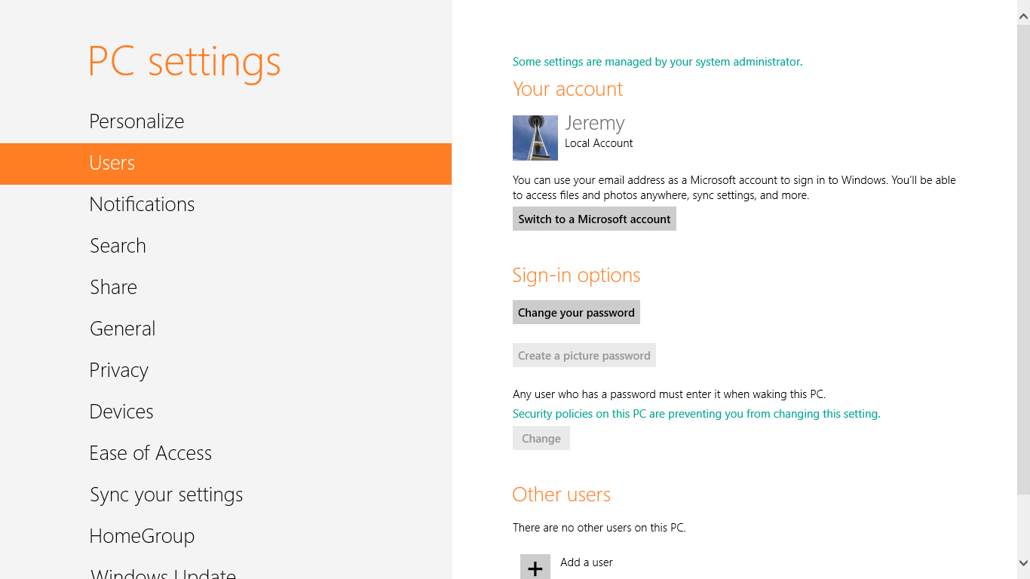

Figure : Users in PC Settings when EAS policies are applied

If you decide later that you do not want to use the Mail app with your Exchange account, you will need to take additional steps to remove the security policies after you remove the account from Mail.

To remove any EAS security policies that have been applied to your user account:

1. Open **Start.**
2. Type **reset security.**
3. Select the link for **Reset Security Policies**. This will open up the **User Accounts** Control Panel.
4. Click **Reset Security Policies** in the task pane on the left.
5. Click **Reset Policies** in the dialog that appears.

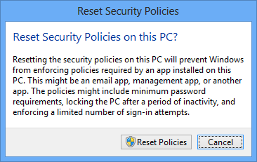

Figure : Reset Security Policies on this PC?

At this point, when you go back to the User section of PC Settings, all of the options that were previously restricted are available to you.

**Warning**: If you use the **Reset Security Policies** option while your Exchange account is still configured, that account will no longer be able to connect to the Exchange Server. In order to restore the ability to connect to the server, you will need to uninstall and reinstall the app from the Store.

#### 10 Device Limit

Some users may run into an issue when attempting to configure Mail to connect to their corporate Exchange server or Office 365 using EAS. Exchange supports a **maximum of 10 EAS devices** connected to a single account. If the user has already connected multiple devices, or if they have reset their device multiple times, they may run into this.

When you run into this limit, the error that is displayed does not provide any indication as to the root cause of the issue, as you can see in the screen shot below.

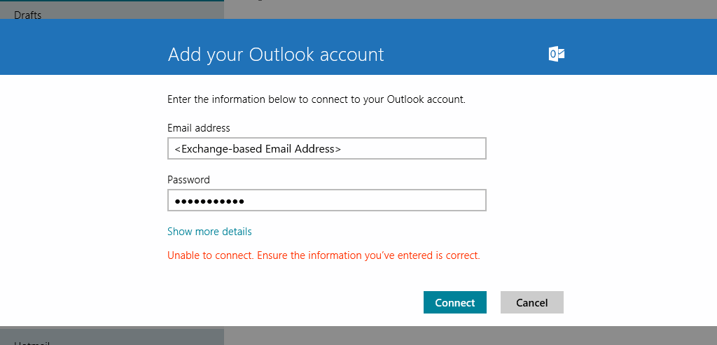

Figure : Error displayed when running into maximum limit for connected EAS devices

After receiving this error, you should also receive an email from the Exchange Server indicating that there was an issue adding your mobile device. An example of this email is shown below. This mail provides instructions for resolving the issue using the Outlook Web App interface (OWA).

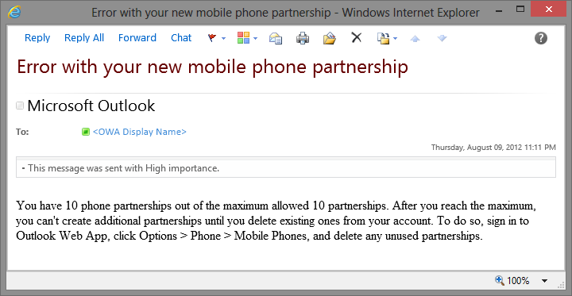

Figure : OWA sends user an email when maximum limit for connected EAS devices is reached

When you log into OWA and follow the instructions, you will see a screen like the one below. This screen will show all of the devices that are associated with this account, the type of device, and the last time that the device synced with Exchange. Use this information to determine which devices can be safely removed, and then do so. After reducing the number of devices in this list, you should be able to configure the Mail app to connect to your Exchange Server.

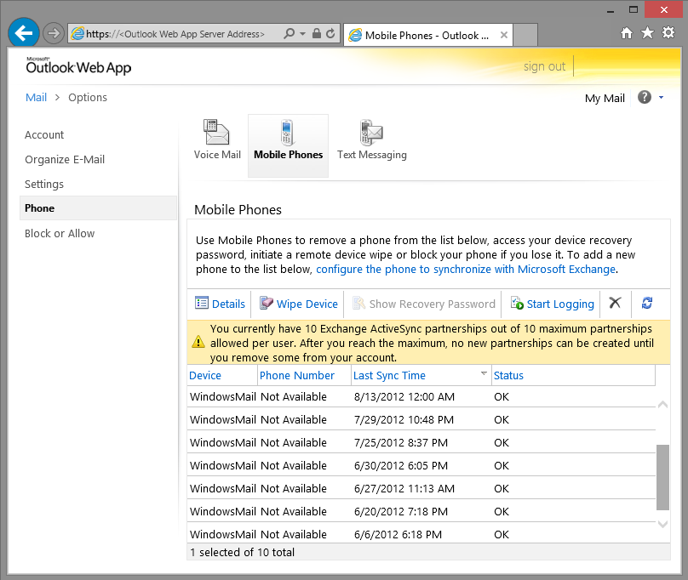

Figure : Managing connected EAS devices from OWA Settings

#### Mail Details

* Attachment limits: You can add a maximum of 1,000 items to an email message. The maximum attachment size is 100 MB.
* You cannot create or delete folders the Mail app. This needs to be done in the mail service (example, go to Hotmail to create or delete a folder and then it will sync to Mail app).

##### Synchronization

* Mail automatically syncs the Inbox and Sent folders when messages are sent or received. Other folders will be set to sync when you open the folder or an action triggers a sync, such as deleting a message. The sync window is set to two weeks by default. You can also choose to sync Mail by selecting the **Sync** app command from the bottom.
* If synchronization exceeds 5 minutes, the process will timeout.
* Possible account sync status states are:
  + Currently syncing.
  + Successfully synced.
  + Error syncing due to incorrect username/password.
  + Account requires EAS policy to be applied.
  + Other error (HRESULT should include hex code of error).

##### Mail Cache

Two weeks of data is cached locally by default. This is configurable in the settings for the account.

#### For More Information

For more information about the Mail app, you can read the following article:

**Building the Mail app**<http://blogs.msdn.com/b/b8/archive/2012/06/14/building-the-mail-app.aspx>

#### Try This: Mail

* Add your Hotmail or another email account to the Mail app.
* Turn on notifications for the account.
* Send mail to someone in your class using the Mail app, and have them send you mail. You should see a new notification appear.
* Snap the Mail app.
* Use the Share charm from Internet Explorer to share to Mail.
* Use the Search charm to search for a message within your email.

### People

People in Windows 8 is a modern take on the flat contact lists of the past―it’s built for the way you communicate today, and it’s connected to the cloud services you already use. The People app helps you keep up with all of the people in your life, by giving you one place to keep all their contact information together and a way to see what they are doing from day to day.

People provides a combined view of all of your contacts across social networking services like Facebook, Twitter, LinkedIn, and Sina Weibo, as well as contacts from email services like Exchange, Office 365, Google, and Windows Live. Any contacts that you have across multiple accounts will automatically be combined into a single view for each contact by the People app.

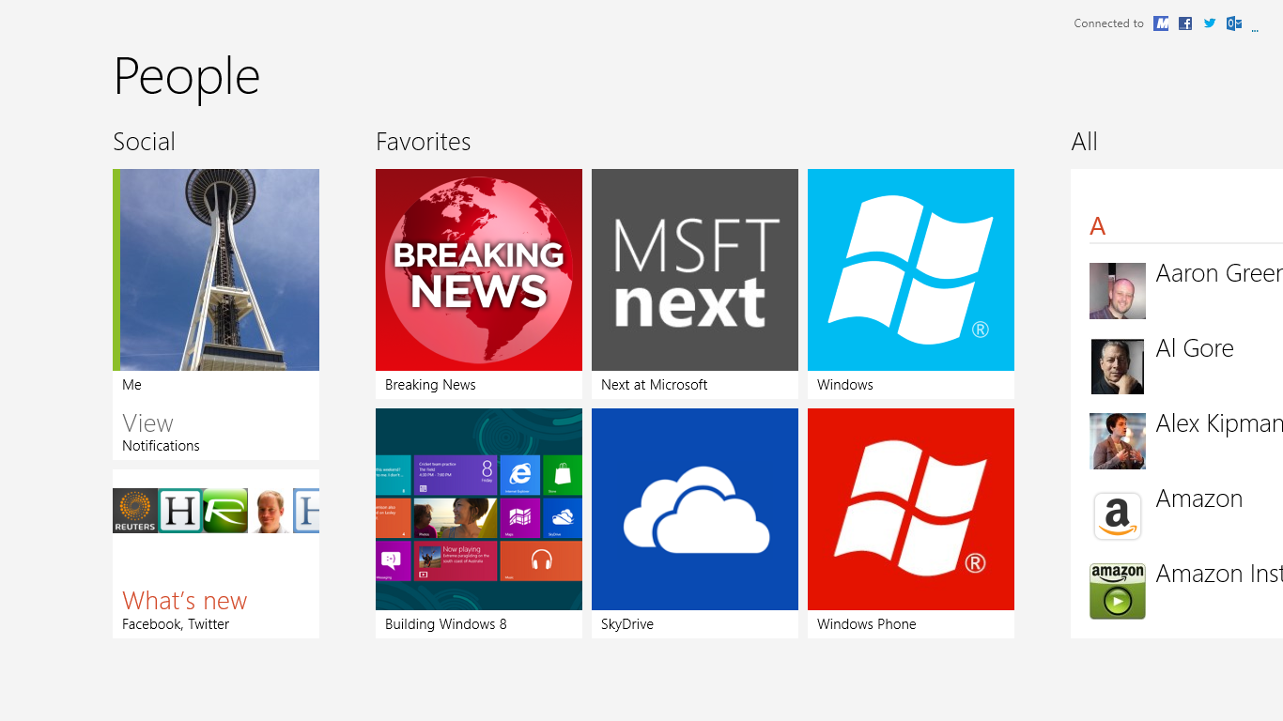

Figure : The People app

#### Home Screen

The home screen of the People app is divided into three main sections:

* Social
* Favorites
* All

From **Social**, you can see any notifications from your social networks, and you can browse all of the posts that your contacts have made under **What's new**. The **Me** tile will display your personal contact page in People, showing your profile information, your recent tweets or posts, and the photos you have stored on your social networks. You can also post to Facebook and Twitter or any other social networks you have configured from here.

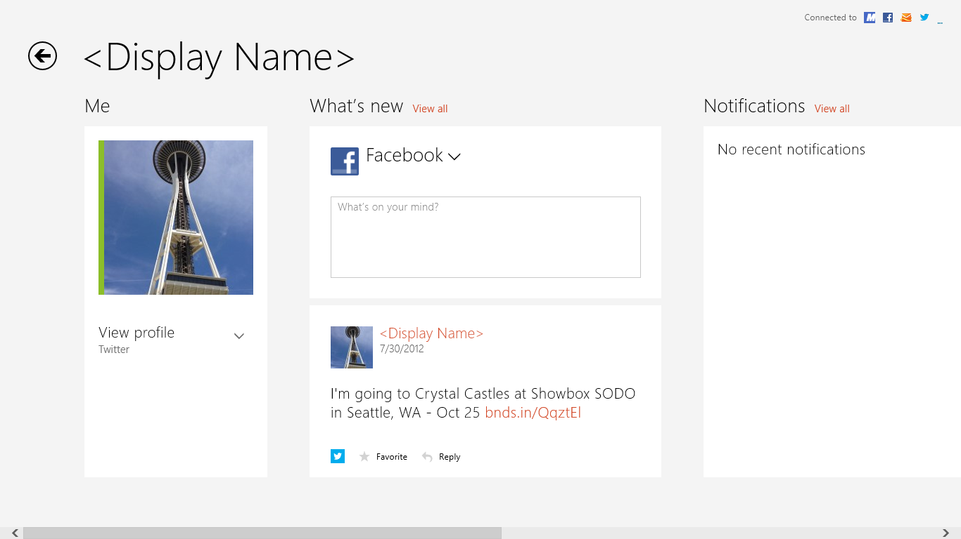

Figure : Accessing the Me tile

After **Social** is **Favorites**. To add any of your contacts to this section, open their contact page, and select the **Favorite** app command on the bottom.

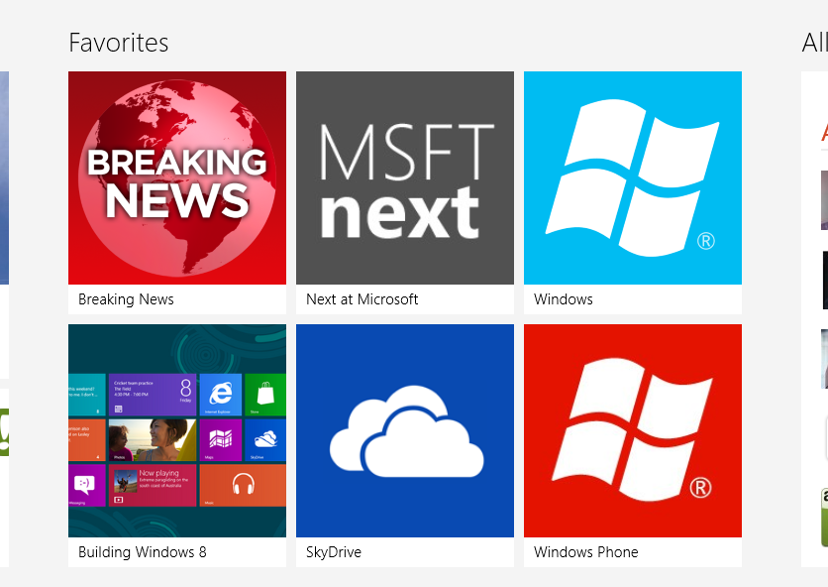

Figure : Favorites on the home screen

The final section is the **All** section. By default, this is a combined view of all of your contacts in one consolidated list. This view includes contacts from all of the email services and social networks that you have configured.

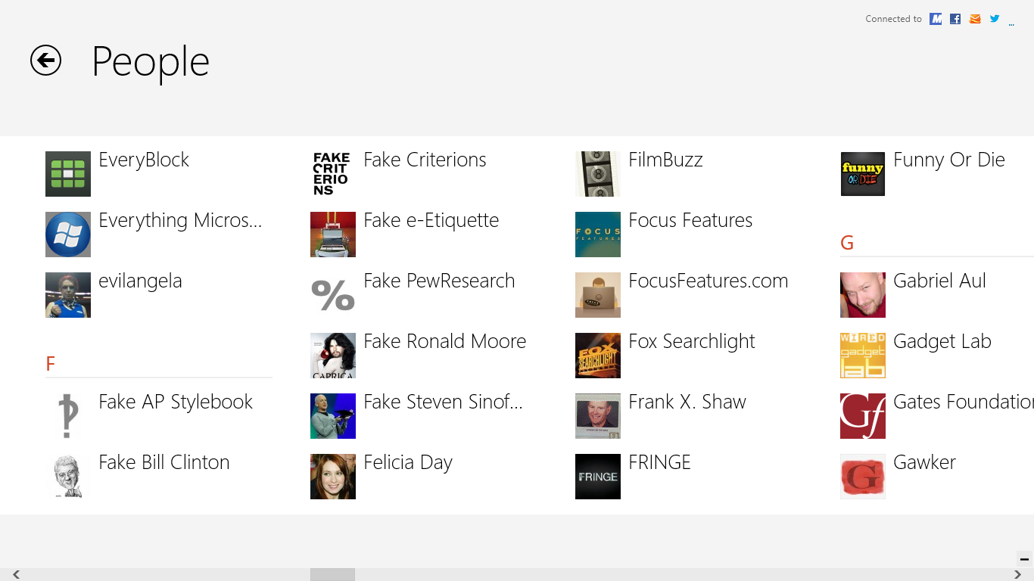

Figure : All section on home screen

You may find it easier to navigate this list by using semantic zoom. Switch to semantic zoom by using CTRL+<Mouse Scroll> or selecting the minus button on the bottom right corner. Select a letter to jump to that location in the list.

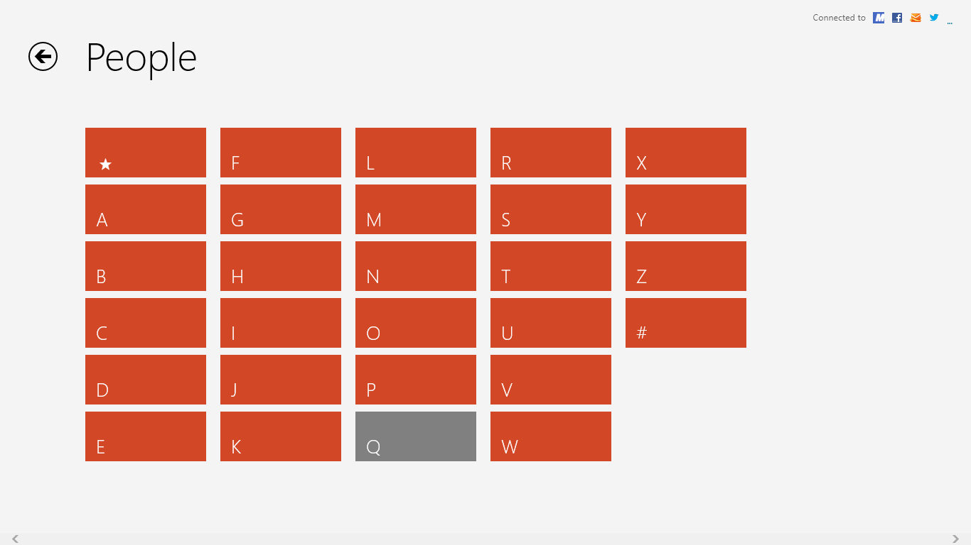

Figure : Semantic zoom from home screen

|  |  |
| --- | --- |
| Of course, if you are just using People as an address book to keep up with your friends and family, you may wish to hide the people you are following on Twitter or your Facebook friends from the main list. You can do this by opening the **Settings** charm and then under **Options** you will see **Filter my contact list**.  Here you will see a list of all the services you have configured with checkboxes that you can use to hide them from the main view.  You also have an option for **Sort my contacts by last name** from here. | Figure : People Options |

You can also quickly find a contact by searching from the home screen for the app. You don’t even need to open Search first. Just start typing and Search will automatically open, similar to searching from the Start Screen.

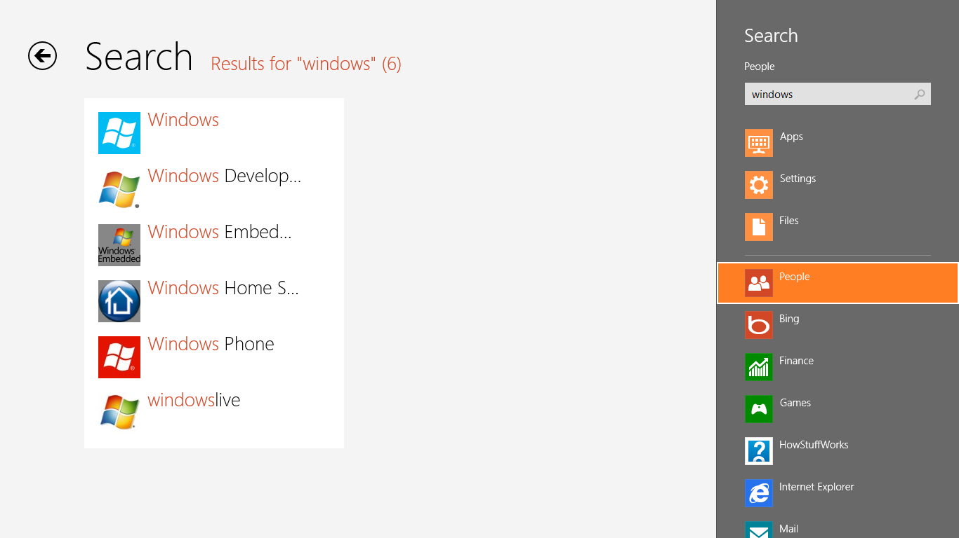

Figure : Search in People

#### What’s New

You can use **What's new** to see updates from all of your social networks. This might include recent tweets from the people you are following on Twitter or posts from your friends on Facebook. Updates from all services will be combined into a single list.

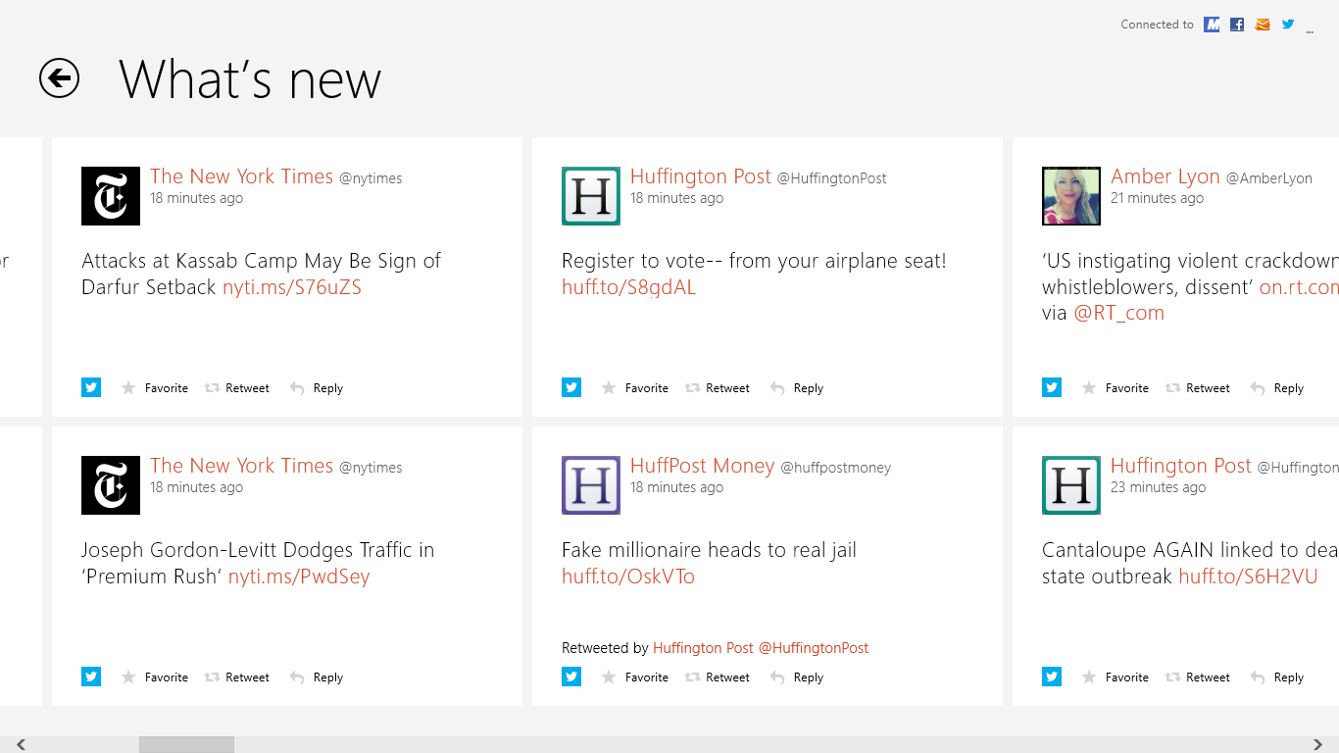

Figure : What’s new

When you swipe up from the bottom or right-click, you can see a **Filter** app command that you can use to view only the posts from one social network. You can also use **Refresh** to check for new posts on all of your social networks.

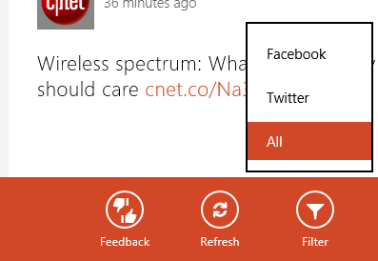

Figure : Filter What’s new to posts from a specific social network

Select any of these posts to see any of the comments or retweets for the post. Additional options specific to the service you are on will also be displayed.



Figure : Post details

* Selecting a Tweet from What's new will give you Twitter relevant actions like retweeting, marking as a favorite, or sending an @reply.
* Selecting a Facebook post will give you options for liking the post or adding a comment to the conversation.

#### Contact Page

Selecting anyone in the list will take you to their contact page. From here you will see a combined view of all of the data you have for that contact across all of your social network and email services. People may display email addresses and phone numbers from Hotmail and Exchange next to photos and wall posts from Facebook and Twitter, all in one simplified view.

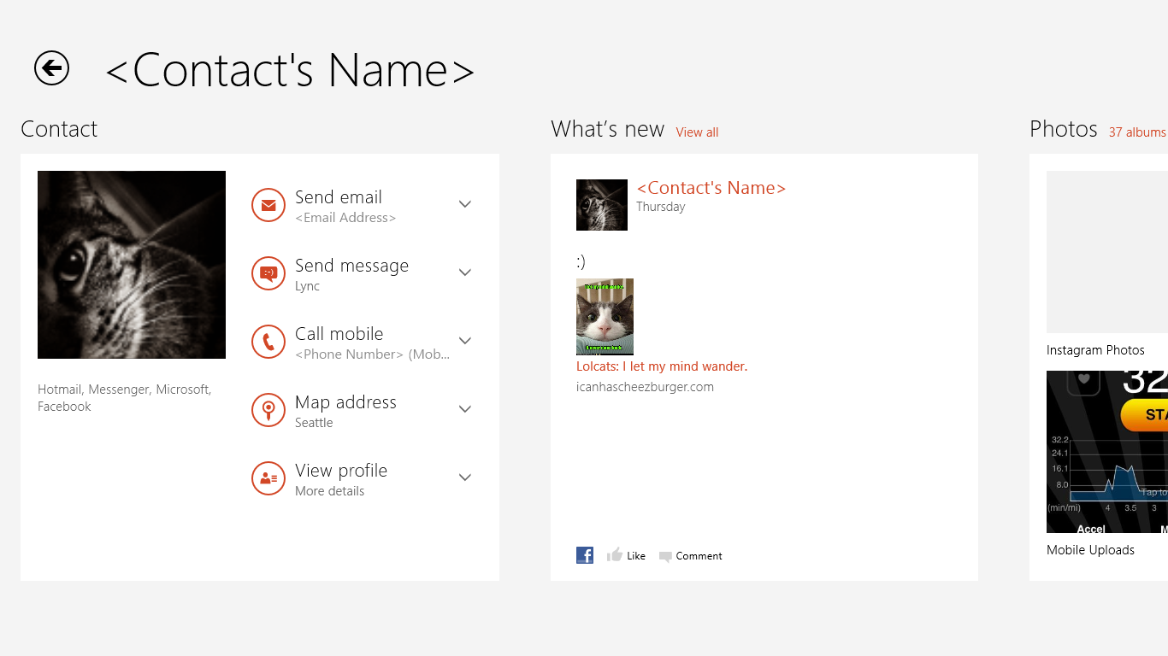

Figure : Contact details

This view is designed to make it easy to get in touch with friends or family, or see what they are up to all in one place.

* The **Contact** section displays some of the common you could contact or look up information about one of your contacts.
  + Send email
  + Send an IM
  + Make phone call
  + Map their address
  + View their profile to see their contact information
* **What's new** displays the recent post this contact has made.
* **Photos** shows you all of the photos this contact has uploaded to their social networks.

You can also see several actions related to this contact when you swipe up from the bottom or right-click.

* Pin to Start
  + **Pin to Start** will create a tile on Start dedicated to this contact. On this tile you will see their pictures and any updates to social networks they make. This is a great way to keep track of your closest friends right from the Start Screen.
* Mark as a favorite
  + The **Favorite** button will add this contact to the Favorites section on the home screen.
* Link other profiles to this profile.
  + This is discussed in more detail in the Linked Profiles section below.
* Edit contact information
  + Selecting **Edit** will display a menu with a list of all of the services that have editable contact information.

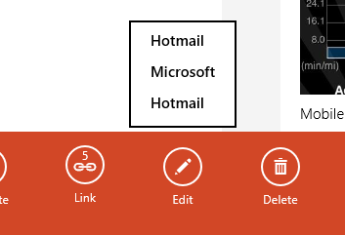

Figure : Edit displays menu with list of mail providers

* + Only email services will appear in this menu. Social networks will not have editable contact information.
  + Select the service from the list to see you the view of their contact information as seen on that service.
* Delete the contact
  + **Delete** is also only available for contacts from an email service. Friends on social networks that are not also connected to an email service will not display a delete button. If you have a contact that is both on a social network and en email service, selecting **Delete** will only delete their contact information from the email service.

#### Linked Profiles

People will automatically consolidate all of the contact information for a single person across several different services, in order to provide one single view of all that information to the user. In most cases, the mapping between two sets of contact information to a single user will be automatic. However, if this mapping does not occur, you can manually link two contacts by opening one of them in People, and then select **Link** when you swipe up from the bottom or right-click. You'll notice that the **Link** button has a number indicating how many different profiles are linked for this contact.

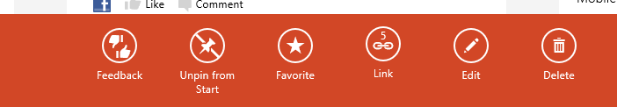

Figure : Select Link to link multiple profiles

Selecting the Link button will take you to a page where you can see a list of linked profiles and suggested profiles that People thinks may be related to this account. You also have the option to manually add a contact using the **Choose a contact** button. Move profiles between the two lists by selecting them. You can link and unlink as needed.

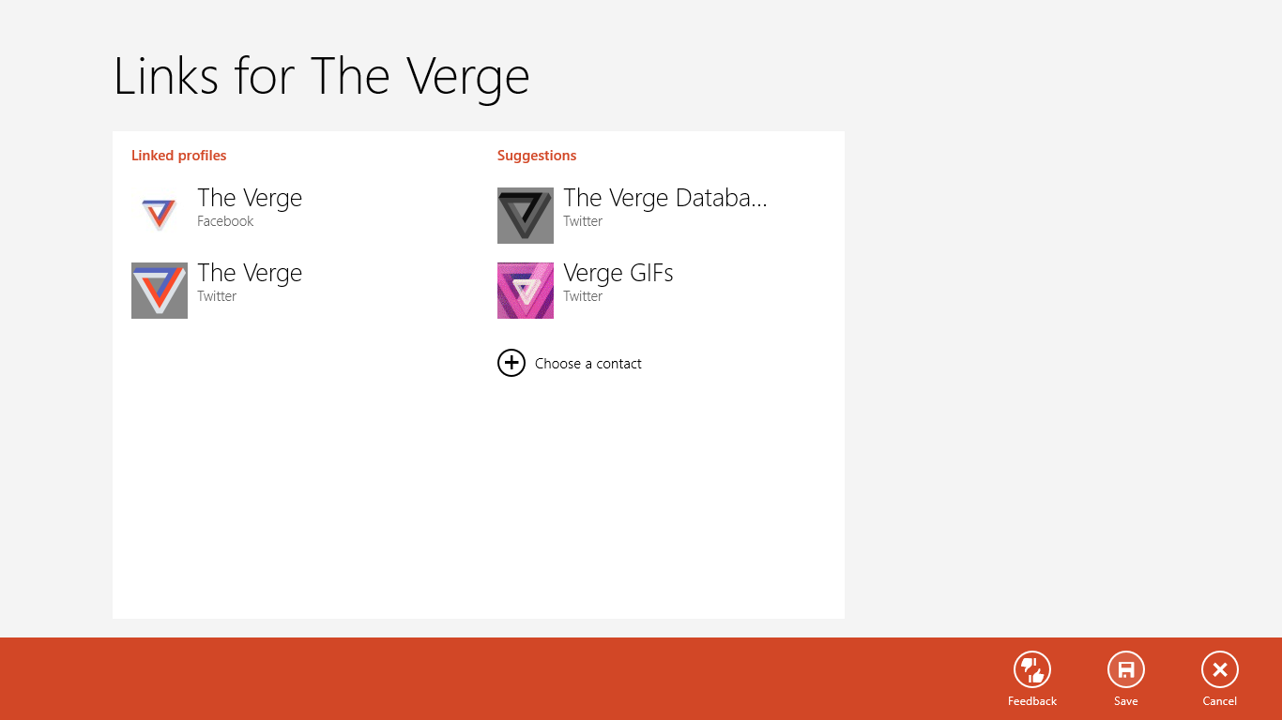

Figure : Link multiple profiles

#### Integrating with Windows 8

Like the other Communications Apps, People takes advantage of many of the new Windows 8 features:

People supports the **Share** charm, which means that any other app that supports sharing can use People as the Share target. If you have Facebook and Twitter configured in People, you'll be able to post to either network using the Share charm.

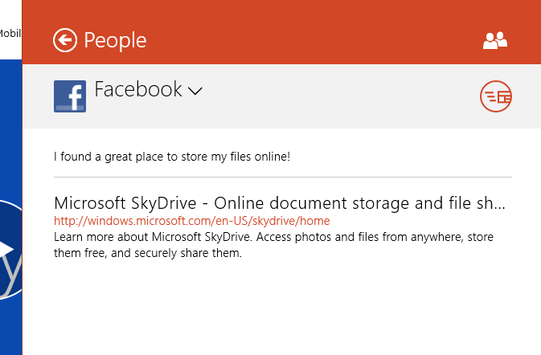

Figure : People and the Share Charm

For any app that needs to provide a way to insert contacts, like the To: line in Mail, can do so using the **People Picker**. The People Picker enables other apps to browse and select from the contacts stored in the People App. There is no need to import all your contacts into these apps, and the apps do not get direct access to all of your contact information. Instead, it loads the People Picker with the app UI, and when you select one or more of your contacts from this list, only the relevant information from those specific contacts is passed back to the app. Using the People Picker also means that you do not need to configure the app with or give access to any or your email services or social networks in order to be able to use those contacts with the app. In the Mail example below, clicking the plus button next to the To: line brings up the People Picker. Here you will see a list of all the contacts available in the People app.

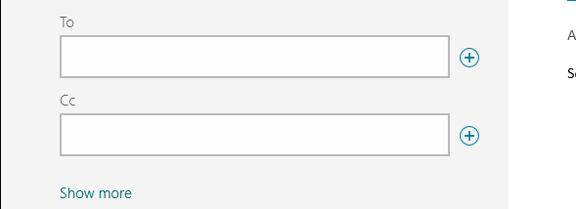

Figure : Click the plus sign to open the People Picker

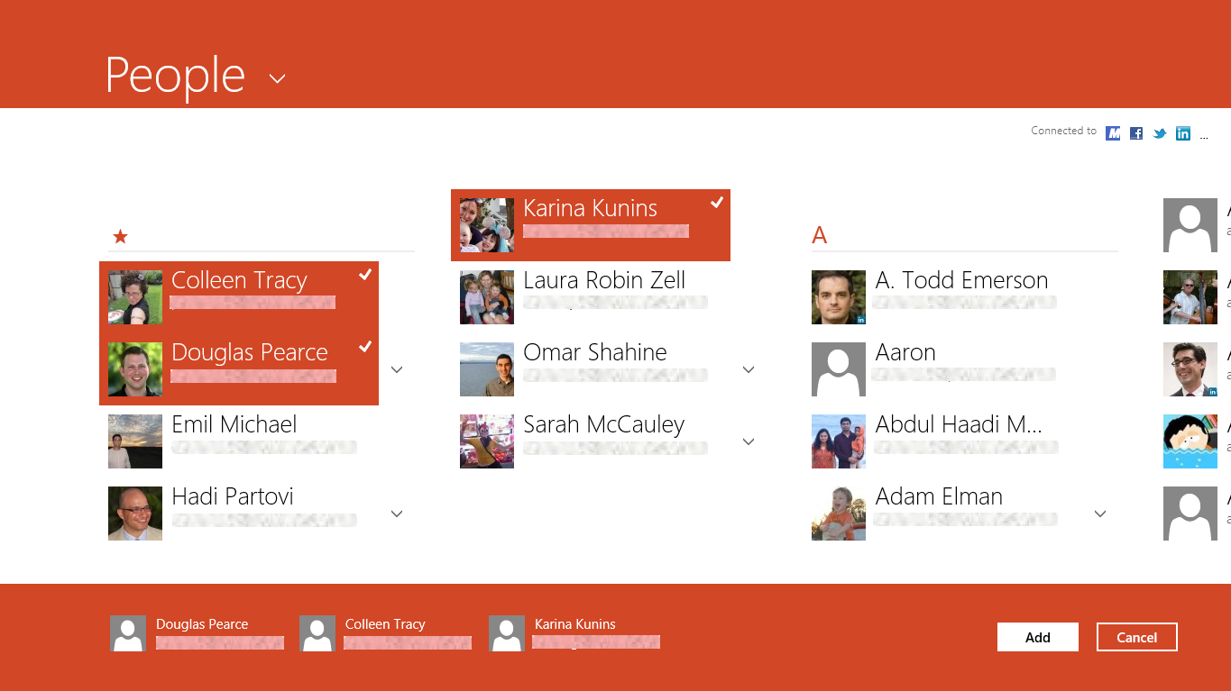

Figure : People Picker

You also have the ability to pin individual contacts to the Start Screen. Each contact that you pin to Start will have their own tile that displays the most recent photos they have uploaded and recent updates to their social networking services.

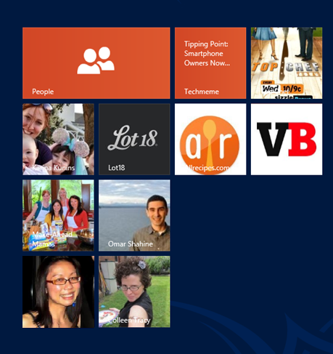

Figure : Secondary tiles for individual contacts

#### People Details

##### Synchronization

* The Always Up To Date (AUTD) mechanism is the engine that manages EAS sync (Exchange ActiveSync) with the server. AUTD will automatically sync with the server every 15 minutes or when a change occurs to a contact.
* There is no option to manually sync contacts. You can use the Mail app to manually force this for services that are configured there as well. That will synchronize Mail, Calendar, and Contacts for the selected account.
* The sync indicator will appear when Mail and Calendar are syncing, even if there are no changes to People. Sync errors will display in the message bar.

##### Status Bar

People uses a shared status bar for displaying status, progress, and error states. The status bar displays at the top of the app.

##### Cache

The People app will provide a limited cache to allow you to add or edit contacts while offline. The changes will be synced when you go back online.

##### Lost Data Recovery

If it seems that data is not presented accurately, compared to web service, the People app should be uninstalled and reinstalled to resync the contacts.

#### For More Information

For more information about the People app, you can read the following article:

**The People app: the complete, cloud-powered address book for Windows 8**<http://blogs.msdn.com/b/b8/archive/2012/06/13/the-people-app-the-complete-cloud-powered-address-book-for-windows-8.aspx>

#### Try This: People

* Connect your Facebook, Hotmail, or Twitter account to the People app.
* Browse the timeline for your social contacts, and “like” a post.
* If you’ve configured a Twitter account, use the Settings charm to filter out those contacts from your main list.
* Post a new message to the service you have configured.

### Calendar

Calendar provides a great way to manage your appointments from a mobile device running Windows 8. The calendar experience is fully dedicated to the calendar itself, meaning that's all the normal buttons and toolbars that are part of most calendar experiences are hidden away from you. The only thing you see by default is the data you care about, meaning the events and appointments that you've added to your calendar.

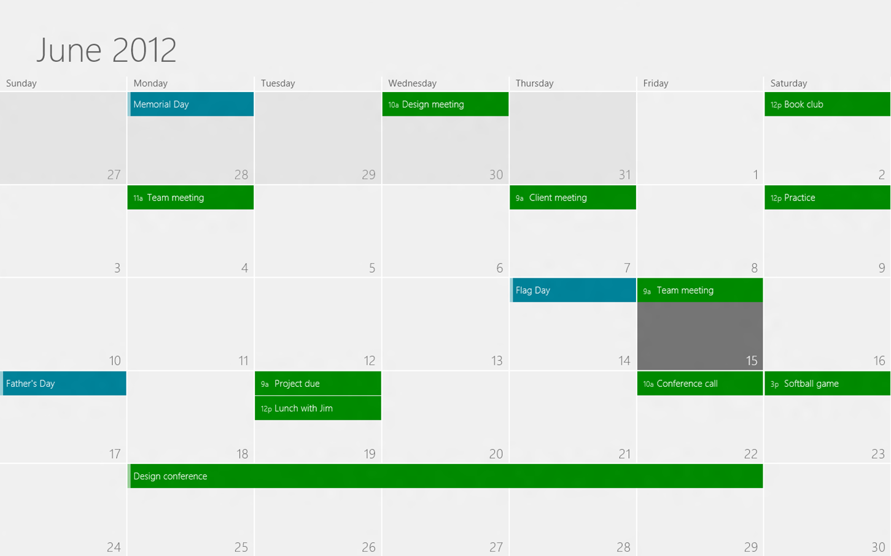

Figure : The Calendar app

Calendar offers multiple views of your upcoming schedule. By default, you were shown the **Month** view, which displays a full seven-day week for five weeks. You can switch views using the commands that appear when you swipe up from the bottom or right-click. You will see options for Day, Week, and Month.

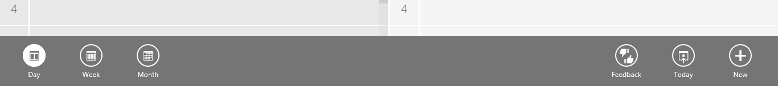

Figure : Switch views between day, week, and month

Selecting **Day** will take you to a two pane view designed to show you the upcoming schedule that you likely care most about, which is the rest of today and tomorrow. Each day is displayed in a list view.

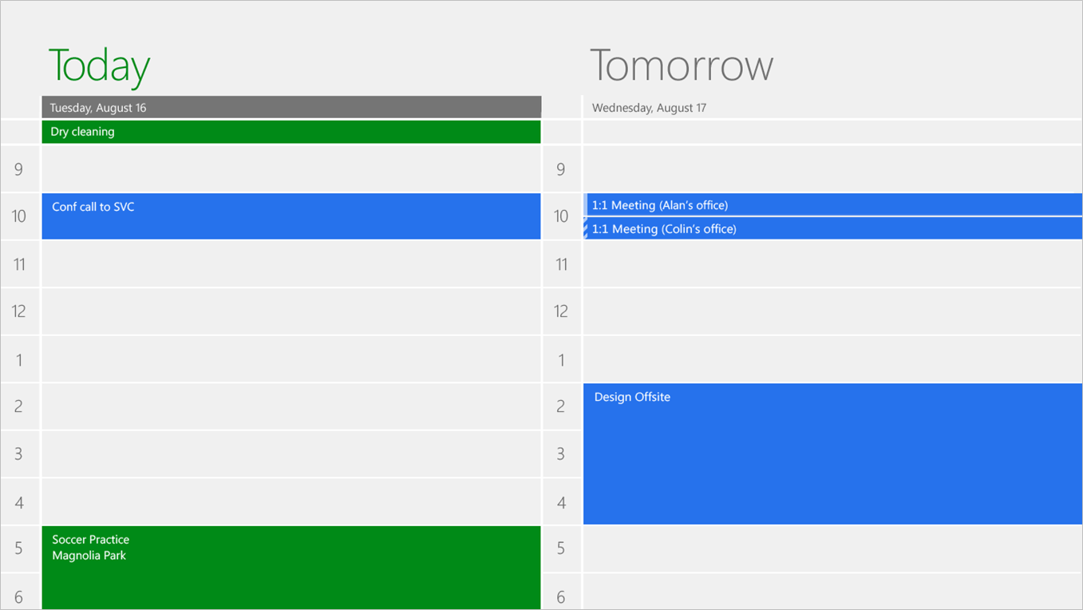

Figure : Day view

The Week view provides a list view similar to the Today you, but condensed to seven days, from Sunday through Saturday.

From any of these views, you can go forward or back in time by using the arrows and the top header of the calendar app. The arrows are only visible when you are moving your mouse, which is why you do not see them in the screen shots above. If you have a touch device, you can simply swipe from left to right or right to left to go forward or backward in time.

**Note:** The Calendar app is intended to be a cloud-enabled calendar, meaning that all of the data you see exists in a calendar on a cloud service. Calendar does not support creating local calendars.

**Create an appointment**

You can easily create a new event in the calendar by selecting the point in time where the event is occurring. You can also use the **New** button you see when you swipe up from the bottom or right-click to create an appointment. Both methods will take you to an appointment screen, which is the same screen you see if you are editing an existing event or creating a new one.

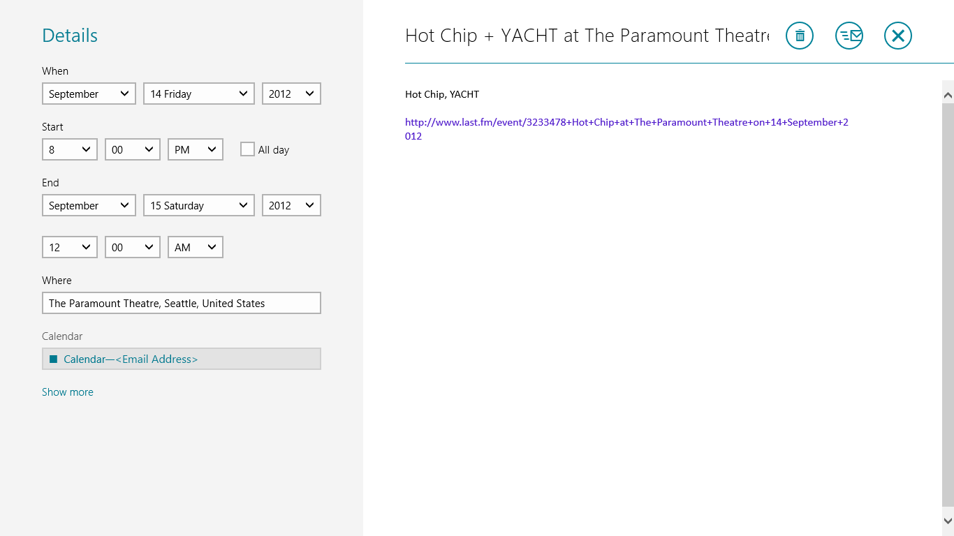

Figure : Appointment view

From the appointment details screen you can set information about the event, such as the date and time, the duration and location of the event, as well as which calendar the event is associated with.

You will notice that each calendar is listed with different colored text. This color represents the color that will be used to display the appointment in the calendar app.

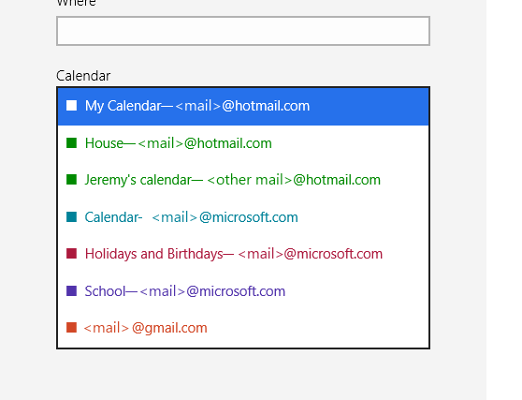

Figure : Calendar menu on Appointment view

Selecting **Show more** will display additional options for things like setting up a repeating event, configuring the reminder, and setting the free/busy status.

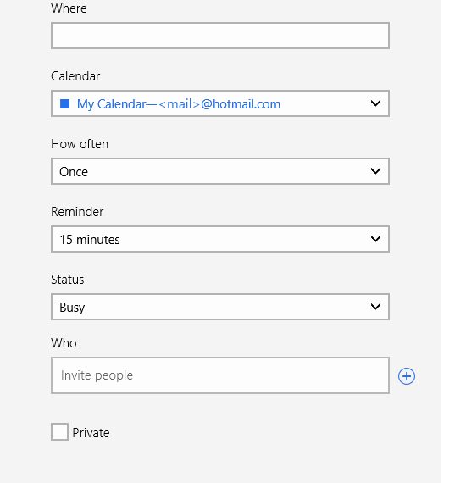

Figure : Additional options displayed when selecting Show more

You also have the ability to invite people to an event. Clicking the + next to the **Who** field will bring up the People Picker, which will display all of the contacts available in the People app. Sending out the invite will send mail to each of the invitees with an ICS file as an attachment. All of the details related to the invite are saved in the ICS file, which many calendaring applications support. In order for one of the invitees to be able to view the invite, they will need an app like Outlook or Windows Live Mail.

|  |  |
| --- | --- |
| By default, all of the calendars that you have configured will be displayed at all times. You can control this, as well as the color that each of the calendars will use to display events by opening the Settings charm and selecting Options. If you want to hide a particular calendar for some reason, just set the option from show to hide, and the events from that calendar will disappear from view. | Figure : Calendar options |

#### Calendar Details

##### Timer Process

The Timer Process is the process by which Calendar decides what events to display in the Calendar tile and Lock screen. The Calendar app runs a background process every 24 hours in order to schedule events for the next two days. In addition, every data change to an event that exists within the two-day window will need to update the event. A timer may also run every time you sign into Windows 8. The timer enables the event information that displays on the Calendar tile and Lock screen.

##### Synchronization

* The Always Up To Date (AUTD) mechanism is the engine that manages EAS synchronization with the server. With this mechanism, Calendar will automatically sync with the server every 15 minutes or when an event changes on the calendar.
* There is no option to manually sync a calendar. You will need to navigate to the Mail app and synchronize Mail, Calendar, and Contacts for a selected account.
* Sync status will display on the Message bar.

##### Calendar Cache

* The Calendar app builds a persistent database cache to allow quick access to the calendar data while navigating through the app. The range of the cache will be 3 months in the past and 18 months in the future.
* If the view makes a query to request data that falls outside of the range of the cache, the app will request that date range from the server. The new data is added to the cache and flagged so it can be tracked as data that isn’t part of the persistent cache.
* The cache can be cleared by removing and re-adding an account in the Calendar Settings. It is also cleared when you uninstall the app.

##### Lost Data Recovery

If data seems to be lost on a calendar, you will need to go to the web service for the account and investigate further. The Calendar app maintains a 22-month cache of data on the local device. If there is a discrepancy between the cache and the data on the server, the cache may be corrupted.

#### For More Information

For more information about the Calendar app, you can read the following article:

**Designing the Windows 8 Calendar app**<http://blogs.msdn.com/b/b8/archive/2012/06/15/designing-the-windows-8-calendar-app.aspx>

#### Try This: Calendar

* Connect your Microsoft account or another account that supports the Calendar app.
* Create a new event in the calendar.
* Switch between the three different views of the Calendar.
* Snap the Calendar to the side of your screen and use that view to create a new event.

### Messaging

The Messaging app enables you to easily chat with your friends in Messenger and Facebook. With a few quick taps, you’ll be sending IMs to your Messenger and Facebook friends. Unlike traditional Messenger, the Messaging app is organized by conversations―just tap a previous conversation to resume it. And no more waiting to sign-in! Messaging works as well offline as online.

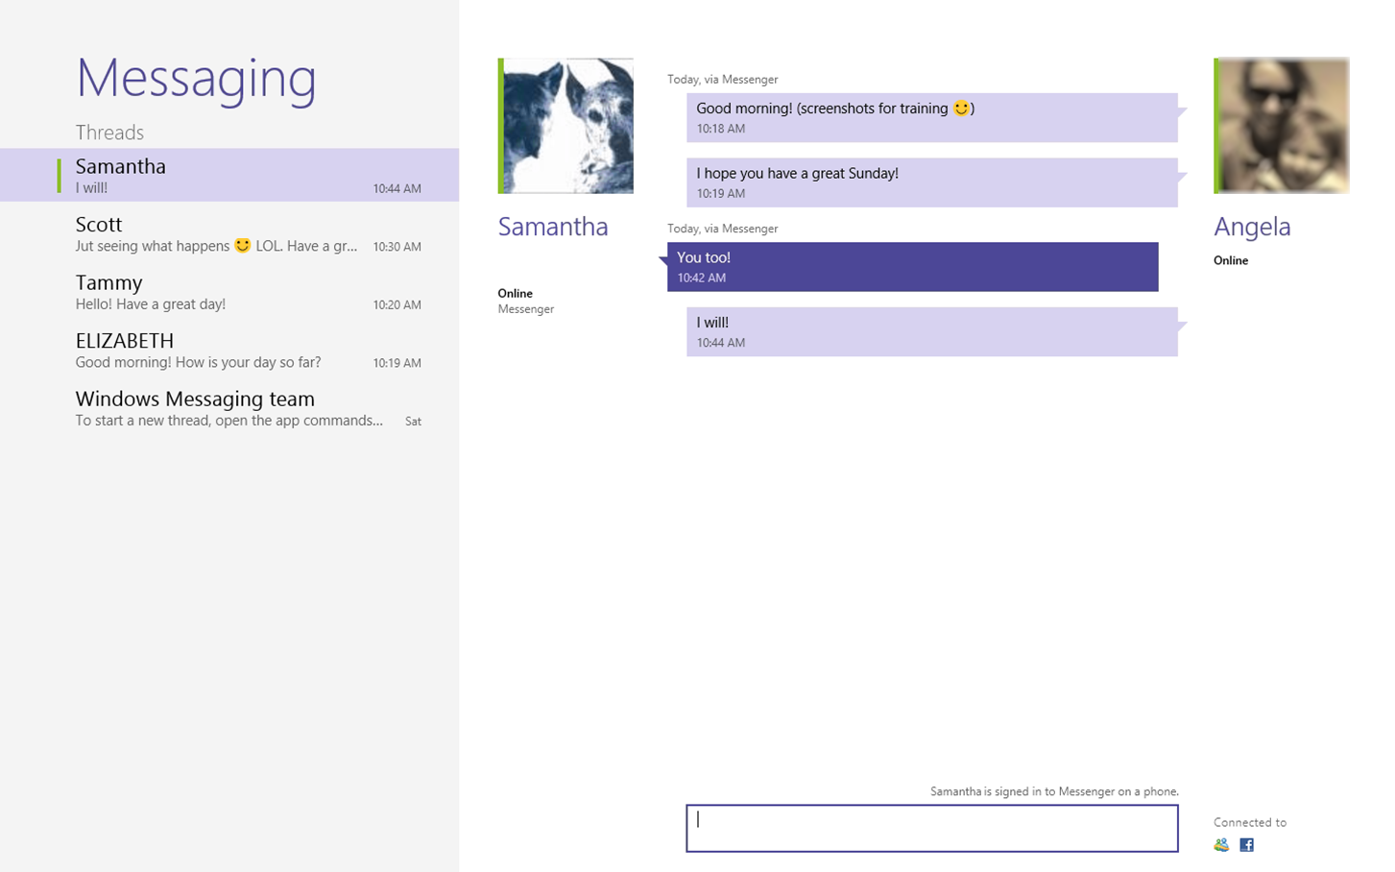

Figure : Messaging app

#### Messaging Details

##### Switch Services

When you configure the People app with multiple services, the Switch action you see when you swipe up from the bottom or right-click will present you with options to change the network you use to send the message. When you switch services, the input area will update with your availability on that network.

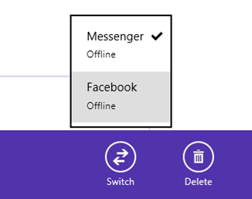

Figure : Switch services

##### Review Chat History

The default behavior is to save the history of your conversations. The interface is designed so you can view and delete conversations as you would SMS conversations on a smartphone. The history list is sorted by the date of the last message in the thread, with the newest message at the top. Select a thread to view, continue, or delete the conversation.

**Note:** A conversation is a set of instant messages sent and received between two users which have a timestamp less than five minutes apart. A conversation divider appears within the conversation area, visually dividing one conversation from the next. The conversation divider will label messages from “Today,” “Yesterday,” or the date of the message for messages older than six days and the day of the week for conversations between two and six days old.

##### Deleting History

You can delete all conversations in a thread. To do this, select a thread from the Messaging List/History area, swipe up from the bottom or right-click, and select **Delete**.

##### Snapping the Messaging App

Messaging is designed to operate in a snapped mode that allows you to multitask while messaging friends. Two separate views are provided while snapped:

* **Threads list view -** Allows you to see the name, status, and a brief preview of the last message in a thread.
* **Conversation view -** When viewing a conversation, a back button is presented, as well as the name of the person you are contacting, his or her presence information, conversation history, and input control.

**Note:** Clicking the People Picker to create a new thread or add a participant to a chat changes the application's state to full screen mode. Also, when the messaging app is oriented in portrait orientation, the application mimics the snapped behavior.

#### Try This: Messaging

* Connect your Microsoft Account to the Messaging app and have a conversation with someone in the room with you.
* Connect your Facebook account to Messaging.

## Photos

The Photos app brings all your memories together in one place―even if they're on Facebook, Flickr, or SkyDrive. Enjoy reliving your memories with stunning and intuitive views. Share your memories easily and naturally using charms.

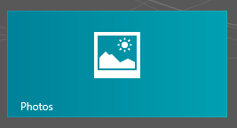

Figure : Photos tile

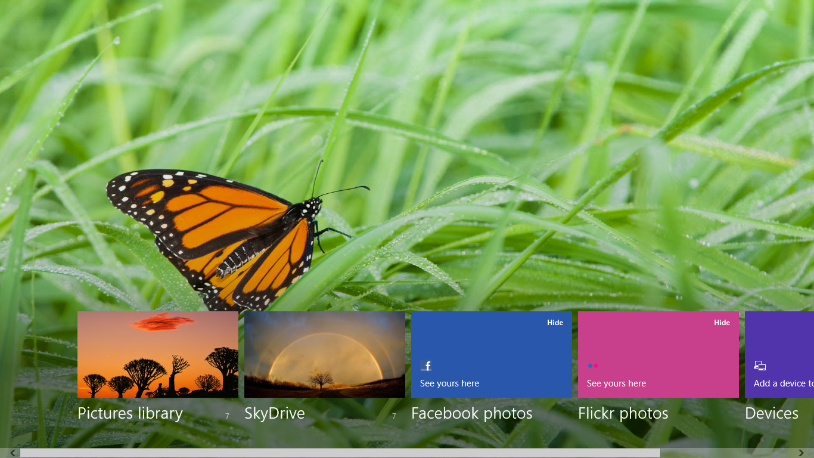

Figure : Photos app

The Photos app can display your picture and video libraries from the following sources:

* **Pictures Library -** Displays photos and videos that are saved to your Pictures Library on your PC. You cannot manage pictures from here, though, because the interface is for browsing.
* **SkyDrive** - Display the photos and videos in your SkyDrive account.
* **Facebook** - Displays your Facebook photos and videos. You need to connect your Microsoft account to Facebook to see these photos.
* **Flickr** - Displays your Flickr photos. You need to connect your Microsoft account to Flickr to see these photos.

### Photos App Details

The following are details about the Photos app:

* When browsing a particular library or service, you easily start a slideshow of all the pictures in the folder you are viewing, or import additional photos from a camera attached to the PC.
* You can also customize which picture that is used for the app tile on the Start screen, the app background, and Lock screen by opening an image and using **Set as** when you swipe up from the bottom or right-click.

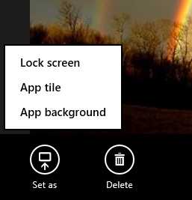

Figure : Set as in Photos

* Sharing photos from the Photos app is easy with the Share charm. Simply select an image (or multiple images by right-clicking on each of them), select **Share** and choose the app you want to share through.

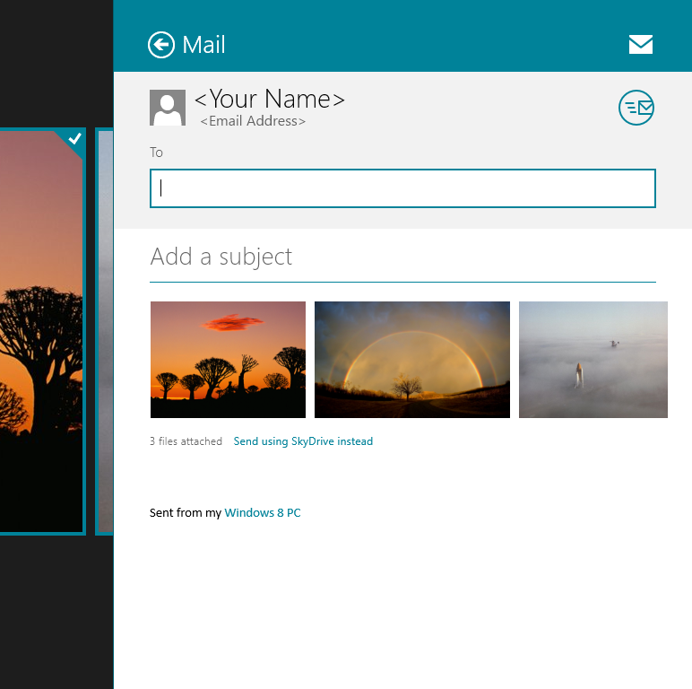

Figure : Share using Photos

* By default, the app tile on the Start screen will shuffle between the different photos you have available. You can turn this feature off in the Settings charm, and then you can directly control which photo is set on the app tile by using **Set as** when you swipe up from the bottom or right-click.
* You can also hide services that you do not use from the same Settings charm.

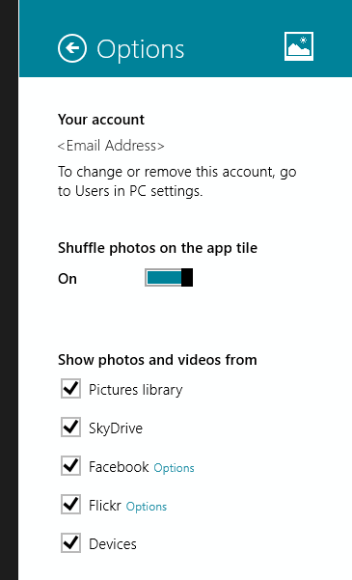

Figure : Settings in Photos

#### Synchronization

The first time you open Photos, it might take a few minutes for the tiles to update and the photos to be available in the app. The amount of time it takes will depend on the size of your collection. You don’t need to wait, though, because you can start browsing and content will be pulled for the album you’re trying to view. Once you’ve seen a photo, it will be cached for faster and offline viewing.

If you just uploaded photos online (for example, using SkyDrive, Facebook, or Flickr), they might not appear immediately. It may take up to 15 minutes for them to appear, so if you do not see your photos, wait and try again.

If the app has an issue connecting to a service, it will show a message under the tile for the service having the issue. This can be caused because of loss of Internet connectivity or issues authenticating (for example, if you changed your Facebook password or removed permissions and the app can no longer access content). If it’s something that can be fixed, the error message will provide a link to the solution. The message should note how long it has been since the last successful sync so you know how out of the date the content may be.

#### Photos Cache

Thumbnails of different sizes are cached locally to improve browsing. Files are only cached once you have viewed them (you have to open a folder in order for the content to be cached).

When you are connected to the Internet, you can see all photo libraries that you have linked to the Photos app. When you are offline, you will still be able to see your photos unless you delete the cache. If you are low on space, the oldest photos in the cache are deleted in order to make room for the new ones.

#### Lost Data Recovery

If photos seem to be lost, you will need to go to the web service for the account (such as SkyDrive or Facebook) and investigate further.

Local photos that are deleted will be moved to the Recycle Bin.

### Try This: Photos

* Connect your SkyDrive, Facebook, or Flickr account to Photos and use it to open and view an album.
* Select an album and start a slideshow.
* Customize the app tile and app background using different images.

## SkyDrive

SkyDrive has evolved into a core part of the Windows experience with Windows 8. It has never been easier to share your data between PCs or from the cloud, and the SkyDrive app in Windows 8 provides a great way to get your data in and out of the SkyDrive service.

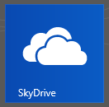

Figure : SkyDrive tile

The SkyDrive app gives you a fast and fluid way to view the data stored in your SkyDrive, and to upload new files there.

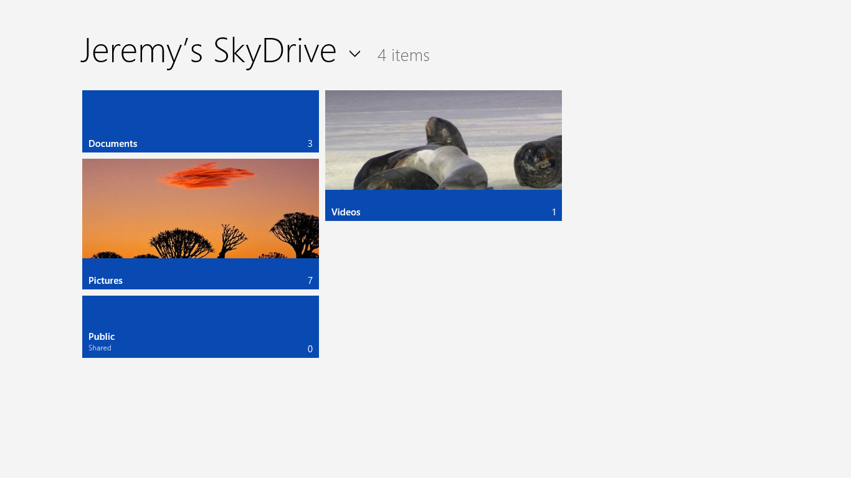

Figure : SkyDrive app

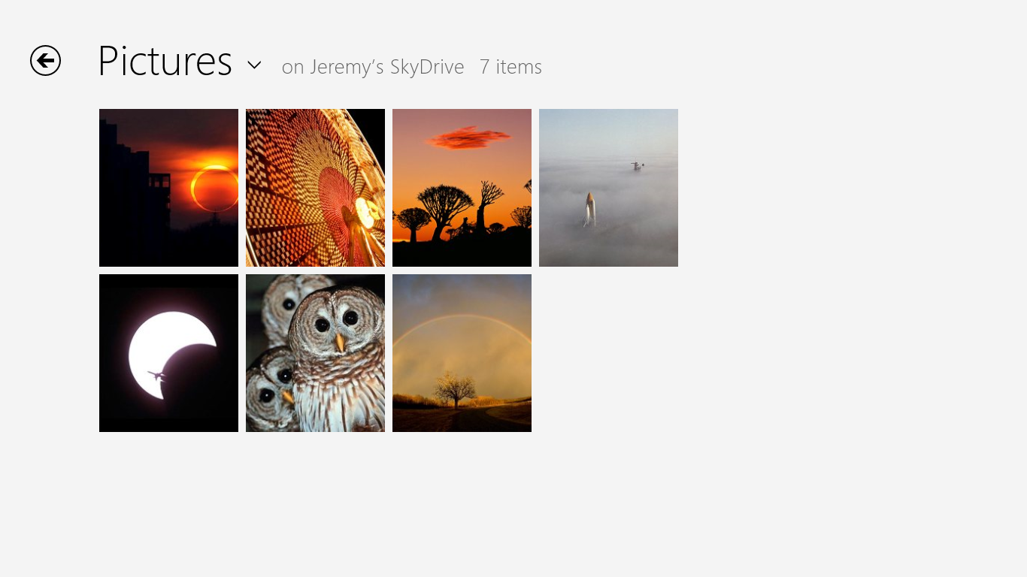

Figure : Viewing pictures in SkyDrive

### SkyDrive Details

#### Uploading to SkyDrive

Use the **Upload** app command at the bottom to send files to SkyDrive. Files being uploaded to SkyDrive need to meet the following requirements:

* The file needs to be smaller than 100 MB.
* The combined length of the file name and path cannot exceed 255 characters.
* The file name cannot use restricted characters such as (\/:;*”<>?!|.
* You need to be connected to the Internet.

If you want to organize the files you are uploading into folders, you can use the **New folder** command to first create a folder, and then once it is created, just navigate to that folder and upload the files.



Figure : SkyDrive app commands

When the file begins uploading, you will see that status of the upload in the upper-right corner.

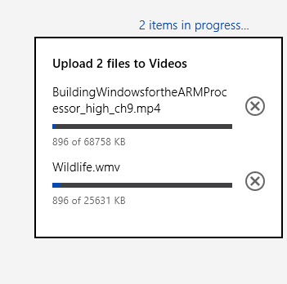

Figure : Upload progress

#### Open SkyDrive Content from Another Application

You can open SkyDrive content in another application. For example, if you want to attach a photo from SkyDrive in Mail, you change the File Picker to point to SkyDrive by clicking **Files** and **SkyDrive**.

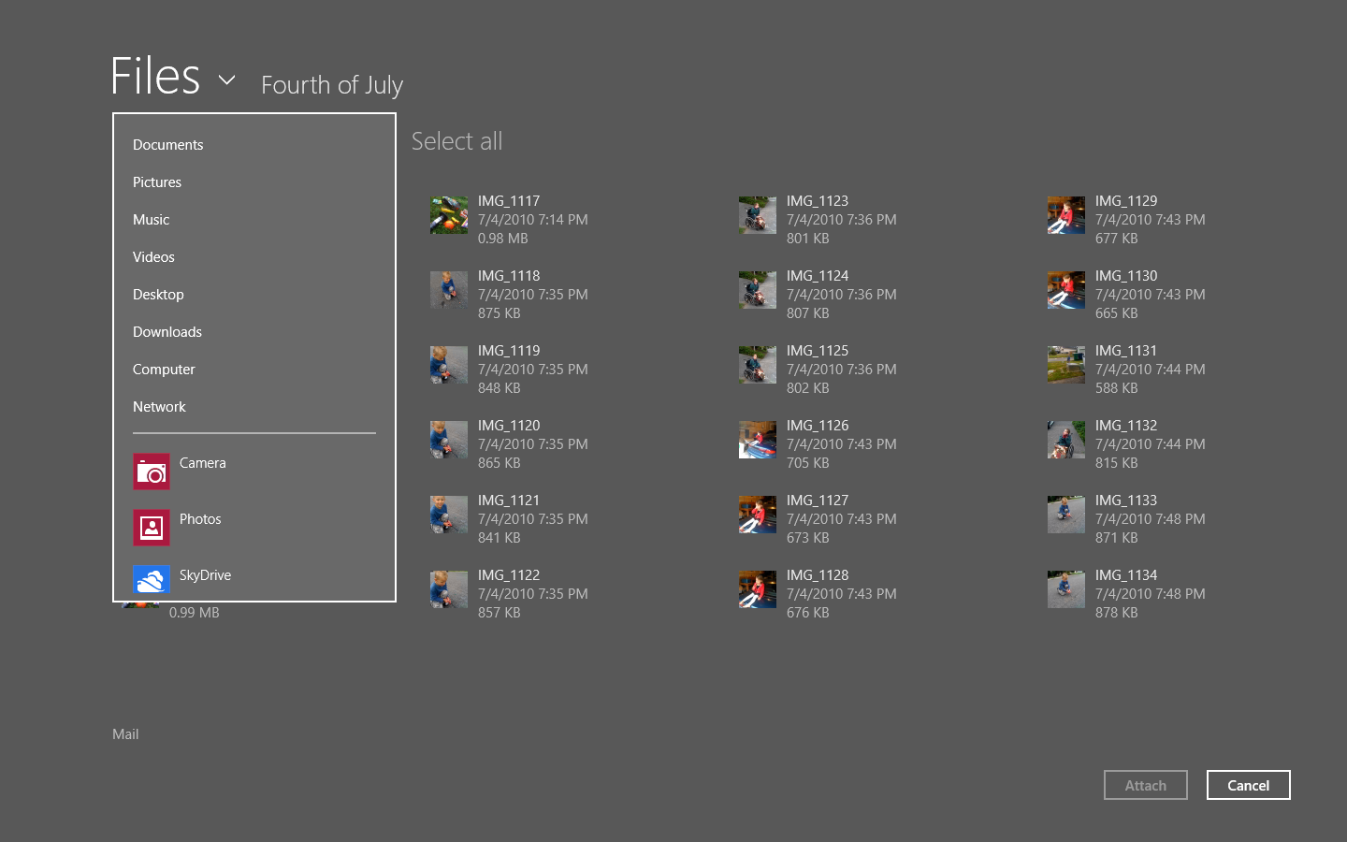

Figure : Browsing to SkyDrive using File Picker

This opens the SkyDrive app and allows you to navigate your folders to select the item you want to attach.

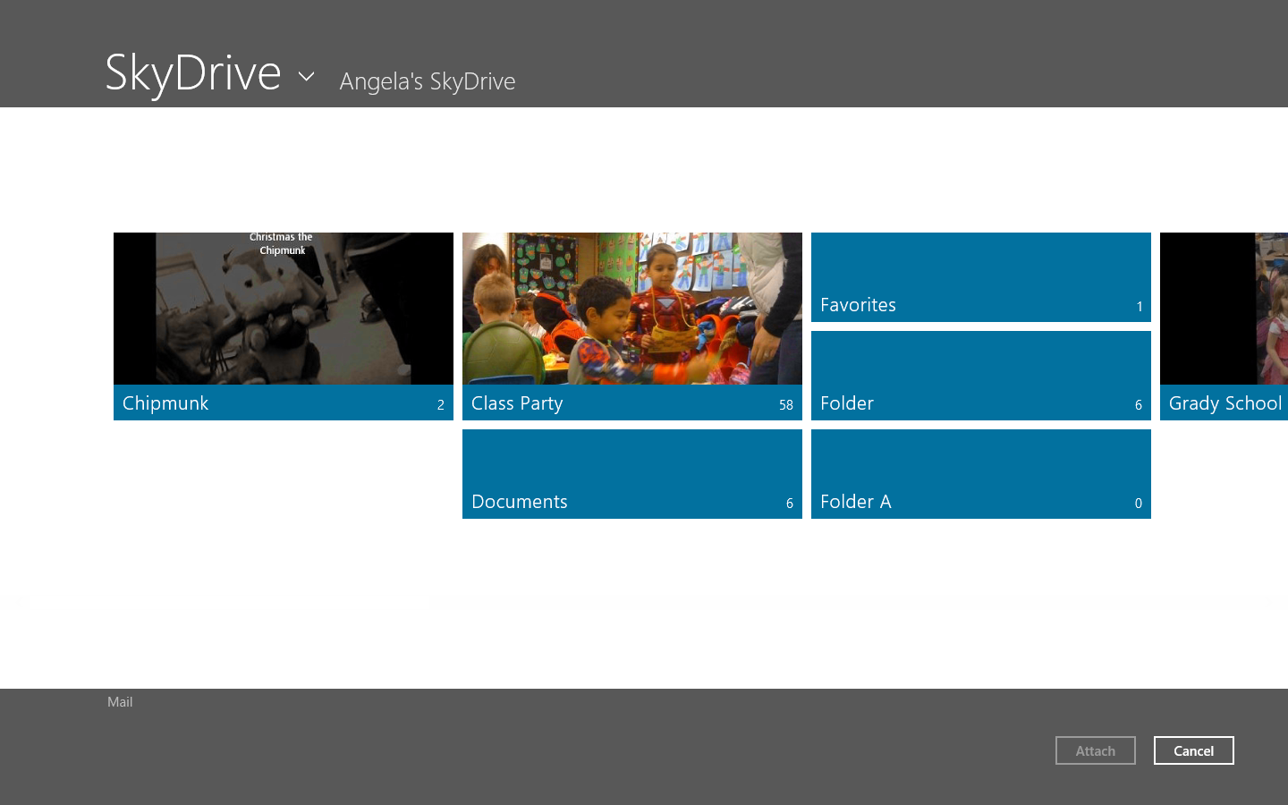

Figure : Navigating SkyDrive in File Picker

#### SkyDrive Cache

Thumbnails and file names are cached, but full data and access to your files is not cached. Use the **Download** app command while connected to make an offline copy.

#### Lost Data Recovery

If content seem to be lost, you will need to go to the web service for the account and investigate further.

#### Error Messages

If your account is blocked due to TOU (terms of use) violation, the following error displays:

There’s a problem with your account. To fix this problem, contact support. The customer clicks Contact Us and is taken to <http://g.live.com/8SESkydrive/BlockedAccount>.